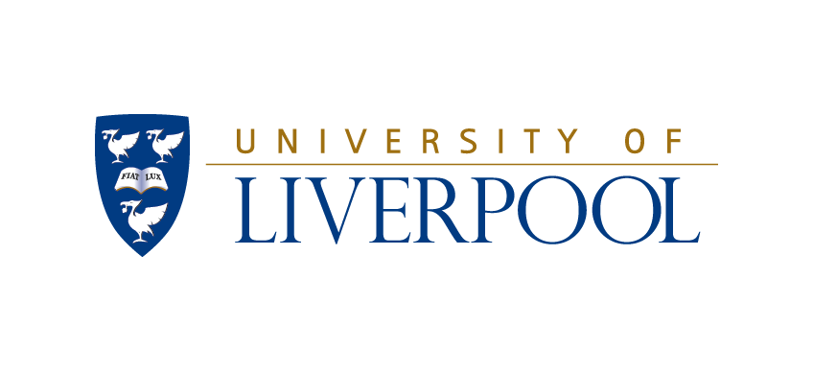
BSc in Veterinary Conservation Medicine

APPLICATION FORM
Closing date for applications 1 May 2025
(late applications will be considered where possible)

Please complete this form (including a signature on each sheet) and send it as an attachment to an email with the subject “Application Veterinary Conservation Medicine” to: bro@liv.ac.uk

Personal Details

Family name

Personal (first) name(s)

Date of birth

Country of birth

Nationality

Area of permanent residence (i.e. county in the UK or, if not UK, country abroad)

Home address

Telephone number

Email

Contact details (i.e. address, telephone number and email if different from above)
Academic details

Current course

University

Date of entry

Qualifications (exams and grades) before entering veterinary course

Qualifications (exams and grades) on the veterinary course

Are you expecting to have completed two full years of BVSc studies by September 2025?

Names, addresses, telephone numbers and email addresses of two academic referees (at least one must be able to comment on your examination results to date on your current course):
Personal statement (max. 1 page) including information on:
- Why you want to intercalate (including previous experience of research)
- Why you want to intercalate the BSc in Veterinary Conservation Medicine (including details of previous experience relevant to the course, eg voluntary work, EMS…)

