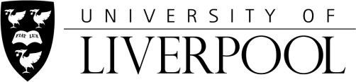

Employer Case Study
Case studies may be used in University of Liverpool promotional materials, e.g. website, brochures and leaflets and on social media (LinkedIn, Twitter, Facebook).

Name of Organisation/Business:

Your full name:

Job Title:

Email Address (work):

Telephone:

Please provide a brief overview of your business, location and key sector(s):

How long have you worked in partnership with the University of Liverpool for? And why did you decide to access training through the apprenticeship programme or recruit apprentices?

Please provide us with a quote about your experience of working with the University of Liverpool.
(what impact has the programme had on the individuals, colleagues, customers, organisation?)
Would you recommend the University of Liverpool apprenticeships to colleagues and friends?

Would you be happy to provide a photograph or corporate image for use with the case study?

Consent
I hereby consent to the University of Liverpool using any images provided (photo or video footage) and or case study information and quotes, as detailed above.
I agree to assign to the University of Liverpool any intellectual property rights to the image and to waive any moral or performing rights I may have or acquire by reason of my participation in such material.

I understand that my image will be securely stored, and may be used on more than one occasion, for a period of three years from the date the photograph was taken. After three years, all images will be confidentially destroyed.

I understand that I can withdraw this consent at any time, by emailing appsliv@liverpool.ac.uk but that such withdrawal of consent will not affect any processing which has already taken place or is taking place.

I consent to my image(s) and case study/quote appearing in the following places:

- University website https://www.liverpool.ac.uk/

- University social media pages (including, but not limited to Facebook, Twitter, Instagram, LinkedIn)

- Social media advertising (including, but not limited to Facebook, Twitter, Instagram, LinkedIn)

- Local press publications

- Internal University print publications (including, but not limited to promotional flyers and posters)

- External University print publications (including, but not limited to, prospectuses, leaflets and posters)

- Print and online advertising (including, but not limited to, local and regional news)

Accepted and Agreed:

Signature:

Date:
Thank you for supporting the University of Liverpool!

