**LEAF User Guide**

# Getting Started

1. Go to the **LEAF login portal** to start [(https://app.ucl.ac.uk/leaf/leaf_external)](https://app.ucl.ac.uk/leaf/leaf_external).
2. Click “**Register**” (Fig.1 - see button above Login). Your username must be your institutional email. Validate via the email sent to your inbox. Once registered and validated, you should be able to login to LEAF.

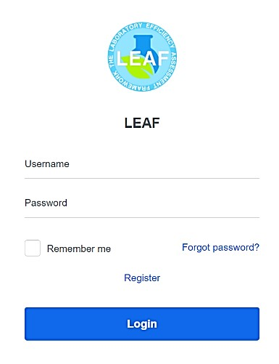

**Figure 1.**

**LEAF Login Page**

1. Login to LEAF. You need to **join an existing lab**, or **request to setup a new lab** if your lab is not listed yet. When choosing the name for a new lab profile, make sure it is easy to recognize by other users and not one that could easily be duplicated by a lab elsewhere e.g. if they use numbers for identification.
2. If joining an existing lab, then this can be approved either by someone already in the lab, or the institutional administrator. If you’ve requested to create a new lab profile, this can be approved only by your institutional administrator.
3. Currently you may **only join one lab**. If you require access to multiple labs, you may request institutional admin rights from your institutional administrator.

# Managing Your Lab

Figure 2 shows the landing page of your lab. You can manage the lab’s profile via the manage lab button at the top right of the landing page. The manage lab functions are outlined below.

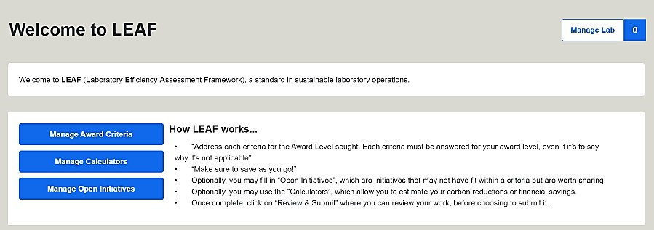

**Figure 2. LEAF User Landing Page**

1. **Lab Details**: Here you can update the lab name, as well as provide context on your lab.

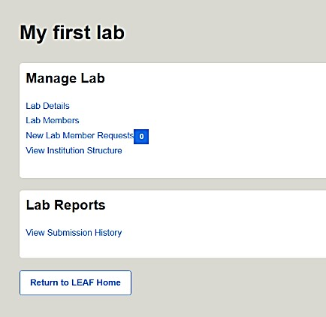

Note that the name chosen here will be printed on your accreditation certificate, but can be changed at any point.

1. **Lab Members**: Here you can manage who is in your lab. You can add new members who have registered to the LEAF platform.
2. **New Lab Member Requests**: Here you can approve new lab members to your lab.
3. **View Institution Structure**: Here you can view how your lab is mapped within your institution amongst the other labs using LEAF. This will be set by your administrator.
4. **View Submission History**: Here you will be able to see any approved

**Figure 3. Manage Lab page**

rejected, or pending LEAF submissions from your lab.

**Completing LEAF**

1. To complete a LEAF submission, you must address the relevant criteria. You can access them via the **Manage Award Criteria** button from the LEAF landing page.
2. To achieve an award level, all criteria must be addressed within that level. If you feel a criteria is not applicable, explain why. Your text will be automatically saved as you input it, but you can still click “Save answers” for assurance.
3. LEAF Progress – You can track you progress on the LEAF landing page. The number of criteria completed for each award level will be shown as in (Fig.4). Icons (such as the clocks below) and the associated colours are outlined in the **Submitting LEAF** section below.

An image showing the LEAF user landing page and the progression of criteria completion. The series incudes now criteria completed, 10 of 16 Bronze criteria completed and all 16 Bronze criteria completed. The grey wheel has changed to green in the third section to demonstrate the level is ready to be submitted for audit


**Figure 4. Series showing progress of completed Bronze award criteria.**

1. The LEAF Calculators and Open Initiatives are optional, but are recommended. Calculators allow you to estimate the carbon reduction and financial saving of actions you have completed. Open Initiatives can be used to share any sustainability progress in areas that are not covered by the LEAF criteria. Both can be accessed using the buttons that are on the LEAF landing page.

**Calculators –** these are intended to capture approximate trends and provide estimates as opposed to exact measurements. To use the calculators, please follow steps below:



**Figure 5. LEAF Calculators**

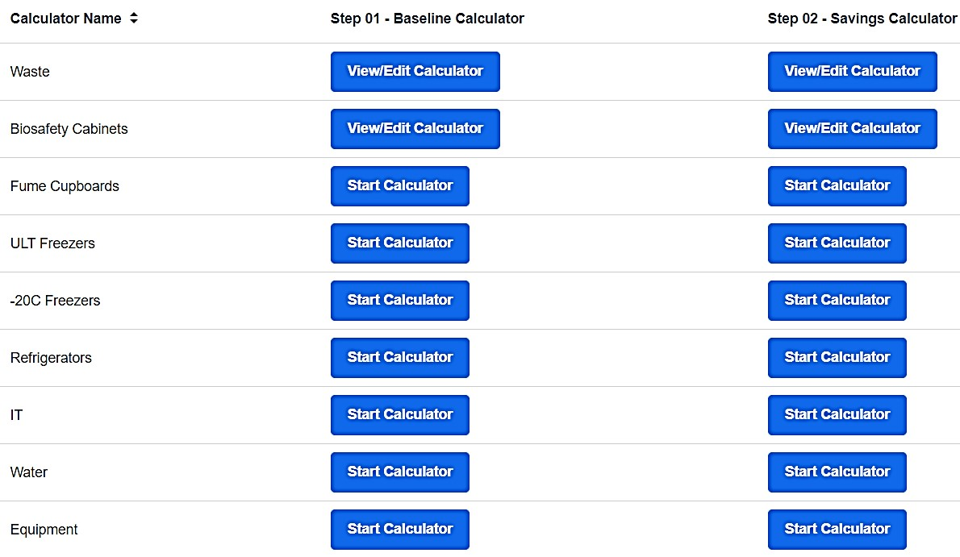

* 1. Click the **Manage Calculators** button from the LEAF landing page
  2. Scroll down the page to see the available calculators displayed as below (Fig.5)
  3. Click on the calculator that you wish to use - Focus on the calculators that relate to areas where you expect to make an impact, as opposed to trying to complete them all.
  4. Fill in the relevant **Baseline Calculators**. e.g., complete the ULT Freezers calculator baseline if you expect to change your ULT freezers operating temperature. If you are uncertain on any definitions or how to find the information needed, scroll down at the bottom of the calculator to find the “Top Tips” and “Relevant Terms” for assistance.
  5. Calculators automatically save your input and there is no need to save as you go. After filling in your data, the calculator should provide the carbon and financial cost of your items at the bottom of the page.
  6. Once the Baseline Calculator has been completed, once ready you may click on the **Savings Calculator** for that same item. Input your data reflecting on the actions you have taken that resulted in a change. e.g., you are using the Savings Calculator for Waste, as you now are recycling more items that would previously been disposed of as general or clinical waste. At the bottom of the page, you will find the financial and carbon cost, as well as the difference between your baseline and savings calculator. If your savings total is a positive number, you have obtained savings. If the savings figure is negative, you have increased your costs since the baseline.

**Open Initiatives** - These should be initiatives which have not been captured by the criteria or calculators, but contribute to the sustainability of your lab. To use the Open Initiatives, please follow the below steps:

## a. Click the Manage Open Initiatives

1. Use the  button on the top right of the screen to create an initiative.
2. Provide a brief description of the initiative. You may estimate savings associated with your initiative (or simply put ‘0’ if there were no savings).
3. Click the **Save** button at the bottom of the screen. This will return you to the Open Initiatives page and the initiative created should be visible.

**Once you have completed all relevant criteria, filled in any Calculators and Open Initiatives, you can submit your LEAF Award for review.**

# Submitting LEAF

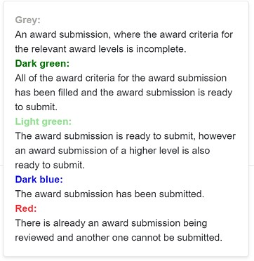

**Figure 6. Icon colour key**

1. On the LEAF landing page click the icon next to the award level you would like to submit.

Note: The icons are colour coded based on progress (see Fig.6). Once you have completed all the criteria for the award level you intend to submit the icon should turn dark green.

1. You will be taken to the **Review and Submit** page which gives you the opportunity to review all that you have completed. You will be able to attach any calculator you have completed that you would like to submit simply by click “**Attach**” next to the relevant calculator.
2. Once you have reviewed all of the information and attached any completed calculators, click on “**Submit Sustainability Assessment**” at the bottom of the page.

Note: It is important to submit for the highest award you are intending to achieve at this stage. e.g. do not submit for Bronze if you are seeking a Silver award.

1. After you have submitted your LEAF Award the icons on the landing page will change colour accordingly.
2. Your Institutional Administrator will receive notification of your award submission and will assign auditors to assess your submission. An auditor or your administrator will contact you to arrange a suitable time to conduct an audit.

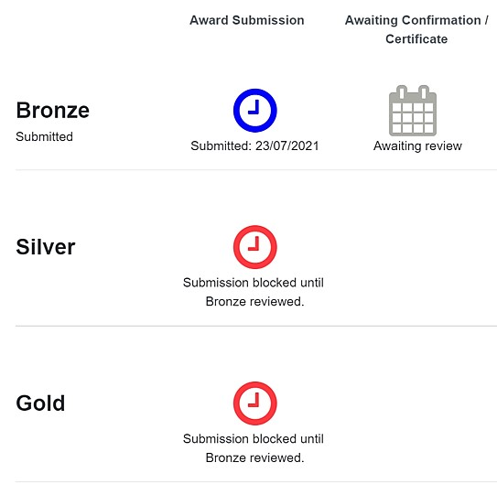

**Figure 7. Award submitted**

1. Auditors may add feedback against criteria in your submission. Once the audit is complete it will require final approval by your administrator.
2. Once an award is approved, the awaiting review icon will be replaced with a LEAF Award logo. Clicking on the logo will allow you to view any audit feedback and download your Award Certificate. Print your certificate, or share on social media!
3. All criteria completed are retained in the award criteria making it easy for you to review this in future and edit as appropriate. They are time-stamped, you will need to review and ensure they are up-to-date each year.
4. As you progress, the award section on the LEAF landing page (Fig.7) will have additional year tabs.

Each year can be selected via the buttons in the top left corner.

# Peer auditing

As a lab member you may be requested to peer audit another lab’s LEAF award submission.

If you are assigned an audit by your Institutional Administrator, you will receive an email notification with the relevant details. You can review any pending audits assigned to you via **Manage Audits** in the top righthand corner of your landing page. On the manage audits page that opens you can view the award submission by clicking **Access Audit** or decline the audit. The steps below outline the process for LEAF peer audits.

1. Contact the lab members to arrange a mutually convenient time for the audit.
2. Read the Auditing LEAF submissions section below
3. Review the award submission in advance of the audit (by selecting Access Audit as above)
4. Provide feedback on the submission in LEAF, on criteria where necessary and general feedback on the award submission.
5. Approve or reject the award.

# Auditing LEAF submissions

To ensure validity of submissions and maintain LEAF standards all submissions should be audited. The exact methodology each institution uses may be self-determined. Guidance on a standard approach to audit LEAF is provided to support institutions. Audit functions are provided in LEAF. Aligning audit standards will improve comparability of LEAF results.

## Auditors

Auditors are to be selected by the institution. There are 3 distinct groups that may be available.

1. Institution administrators - involved in managing the LEAF program
2. Peers - members of another participating LEAF team
3. Students - in associated subjects

Any of these groups or any combination of them could conduct LEAF audits. Benefits exist for each of the groups. All auditors should be familiar with LEAF content and laboratory environments. In total, there shouldn’t be more than 3 people on an audit team. Any registered LEAF user at your institution can be assigned LEAF award submissions to audit by the Institutional Administrator.

## Audit Scope

Audit all content submitted by the lab via the LEAF tool. All criteria are time stamped and auditors may wish to review when content was last updated. During the audit any non-performance should only be recorded if relevant to LEAF criteria. Record all relevant good practice even if it falls outside of LEAF criteria as it could serve as inspiration for future criteria or case studies.

## Audit Process

Audits should take approximately one hour. Avoid exceeding an hour, unless the facilities being audited represent an unusually large submission (e.g. Gold Award for a large institute). Audits should ideally be conducted in person but where scheduling is challenging, they can take place remotely on a platform of your choice. Audits should be scheduled in advance. During the audit add constructive comments in the feedback section for the criteria assessed.

There may not be sufficient time to assess every criteria, particularly for Gold or Silver submissions. Focus on challenging, recently completed, or unclear criteria requiring more information. Labs are not required to provide additional documented evidence, but auditors should note criteria which they may want to inspect in person at a later date if unable to access during the audit. If calculators have been submitted focus on how savings have been achieved. If Open Initiatives have been submitted, discuss the methodology and any estimated savings.

On completion, always thank the laboratory for participating and auditors for their contributions. The audit team may want to spend 5-10 minutes reviewing results and agreeing the outcome after the audit without the auditees present.

## Assessing the Criteria

Each criteria addressed by the auditors must be assessed as either Pass or Fail. At least 70% of the criteria must be passed at each level in order for the award to be made. A guide to assess each criteria is provided at the end of this document. Experience and familiarity with laboratories should permit auditors to determine Pass or Fail using the ‘target outcomes’ and ‘failure rationale’ provided.

If the lab is yet to fully achieve a criteria but demonstrate a clear pathway is in progress the overall submission may be approved, but this should be recorded for subsequent submissions (this will drive continuous improvement). ‘N/A’ is an insufficient response to a criteria, a short reasoning must be recorded. Where a laboratory addresses criteria by providing a rational explanation for why it is unachievable in their current setting, it is acceptable to assess the criteria as a Pass.

It is not necessary for all criteria to be updated by the lab on each round of submission. All criteria are time stamped to enable auditors to see when this was last updated. Auditors should use their discretion to assess whether criteria is being achieved and when to suggest an update or amendment is required.

To be successful at each level, the following number of criteria need to be passed:

|  |  |
| --- | --- |
| **Level** | **No. of criteria to be passed** |
| Bronze | 13 out of 18 |
| Silver | 12 out of 17 |
| Gold | 11 out of 15 |

Avoid spending too much time on any single criteria, no more than 2-3 minutes ideally. Conduct audits with a positive attitude, be congratulatory, and provide encouragement. When faced with failed criteria, seek to understand why, but do not make the audited laboratory members feel like they’ve failed. If criteria are repeatedly failed from previous submissions, make these targets for future LEAF submissions and agree a timeline before the lab can progress further. Should any users refuse to answer any questions, or cannot provide a satisfactory reasoning, simply record this to feedback at a later point. Always remain positive with participants.

## Final Evaluation and Certification

When the audit is complete auditors should have discussed any uncertainties and had an opportunity to address questions. Auditors should agree an outcome without the lab members present. If any criteria have not been met, the lab may still achieve its award if it agrees to address this in an agreed amount of time, and the auditors feel the pathway to this is demonstrated and achievable.

Following the audit, notable feedback can be entered by auditors next to each criteria on the LEAF Review Award Submission page and general feedback can be provided at the bottom of the page. Use the button beneath the feedback box to approve the award.

**Following a round of audits, celebrate the labs successes and share LEAF results!**

LEAF Criteria assessment guidance is provided in the pages below for those conducting LEAF audits. For each criteria ‘target outcomes’ and ‘criteria not met’ rationale is provided. The guidance is organised in tables for each LEAF criteria section.

## This guide has been produced to support LEAF lab members and peer auditors, for further information or support please contact [LEAF@ucl.ac.uk](mailto:LEAF@ucl.ac.uk)

**LEAF Criteria Assessment Guidance**

|  |  |  |  |  |  |
| --- | --- | --- | --- | --- | --- |
| **#** | **Level** | **Category** | **Criteria** | **Target Outcome** | **Criteria not met** |
| **1** | **Bronze** | **Waste** | The lab possesses required waste bins (possibly clinical, glass/sharps, hazardous etc.), as well as recycling/general waste bins with appropriate and clear signage. Standard operating procedures for the management of lab waste are available to all lab users who will have been made aware of the procedure to follow for correct waste disposal. | •   Appropriate bins are present to easily recycle items particularly packaging. | •   Recycling is feasible, but no bins are present. |
| •   There is clear signage in place depicting which bins are for what purpose. | •   Bins have no signage. |
| •   Details of how this has been communicated can be evidenced. |
| **NEW 1** | **Bronze** | **Waste** | Lab users disposing of hazardous/radioactive wastes have received specific training and records of this are kept. Training gives consideration to what to do in the event that it is discovered that hazardous/radioactive wastes have been incorrectly disposed of. | •   Training records are available | •   Users do not know appropriate waste routes |
| •   No training records are available |
| **2** | **Bronze** | **People** | The lab has a mandatory sustainability induction procedure in place for all new arrivals, explaining the sustainable practices to take. The induction would benefit from being documented to allow users to revisit the training and refresh their knowledge. | •   There are viewable induction materials containing sustainable practices, specifically closing fume cupboards, turning equipment off, chemical/ sample management, and waste practices. | •   New lab members are inducted, but without relevant sustainability practices. |
| **3** | **Bronze** | **People** | The lab has a system in place to clear or track materials left by departing staff. All lab users have been instructed on what to do with their materials when they depart. | •   There must be a system in place to ensure old materials do not go unmanaged e.g. through an exit tracking document. | •   There is no system in place to catalogue materials of departing staff and students. |
| **4** | **Bronze** | **People** | The lab has either a nominated person or group to drive sustainability forward. They should all be lab members within the online LEAF platform. Sustainability has been added as a standing agenda item into lab and/or departmental meetings and/or relevant networks (e.g. Health & Safety) | •   One or more people have the responsibility of leading on sustainability. This is communicated in some fashion to all lab members. | •   There are no plans in place for continuing sustainability efforts, either as a group or individually. |
| **5** | **Bronze** | **People** | The lab (or relevant group) has taken part in 1 team activity of sorts over the course of the year, or one is imminently planned. | •   The lab can evidence at least 1 activity within the past 12 months or have one imminently planned | •   No social activities have taken place within the past 12 months, and none are planned. |
| **NEW 2** | **Bronze** | **People** | The lab has taken action to address the energy and environmental impacts of their lab operations under normal operating conditions, abnormal conditions e.g. small chemical spills that can be safely controlled locally, and emergency conditions e.g. large chemical spills that require external help. Existing documentation is updated as part of its review cycle to support this process. | •   The lab has undertaken a review of how it is operated e.g. when/how equipment is used, through risk assessments and COSHH forms as required to determine its impact and users are aware of efforts to reduce this in all eventualities | •   The lab has not considered impact during abnormal or emergency scenarios. |
| •   Opportunities to review and update documentation have not be taken. |
| **6** | **Bronze** | **Purchasing** | Energy and materials consumption have been considered during the purchase of new materials. Ideally users should request life-cycle assessments (LCAs), though should be prepared for vendors to not have these available. Lab users have received information or know where to find out how this should be approached. | •   Examples of when and how energy/water consumption, consumables, and durability have been considered in any recent purchases including evidence from suppliers. | •   Equipment purchased within the past 12 months was purchased considering price only, and otherwise more sustainable options were not considered. |
| •   In the absence of any purchases, users must display an understanding of how to purchase sustainably for when such a time arises. | •   Purchases have not factored in energy/water consumption, consumable use, durability, or manufacturing location, or servicing. |
| •   Applies only to equipment in which more efficient options are available which won’t affect the equipment’s output. E.g. freezers, safety cabinets, or drying cabinets. |
| **7** | **Bronze** | **Equipment** | There is a system in place to ensure that heat sources on cold storage equipment (fridges, -20 and ULT freezers) are not blocked, and any filters are cleaned regularly. Details of responsible person(s) for ensuring this is done are communicated to all lab users in a way that allows others to easily identify who they are. | •   There are no items blocking the expulsion of hot air, excluding underbench units. | •   Heat sources are visibly blocked by items which may otherwise be moved, or there visibly blocked filters with no plans to clean. |
| •   Any freezer filters are cleaned regularly, or there is a plan to clean within 3 months. |
| •   Lab staff are aware of who the responsibel people are in their organisation |
| **8** | **Bronze** | **Equipment** | There is a system in place to ensure that cold storage equipment (fridges, -20 and ULT freezers) and ovens are only operated when they are as full as possible. The need to do this and reason why has been communicated to all lab users either as part of their induction or as they start using the equipment. | •   There are no ovens, cold storage, or similar equipment operating when empty, unless for a specific purpose. | •   Equipment is in operation with no items inside, and no reason why they’re on. |
| **9** | **Bronze** | **Equipment** | There is a system in place to ensure equipment and lights are turned off when they are not needed. Equipment this applies to is clearly marked and staff receive regular reminders to turn off the lights when they are not needed. Your response should include how you do this. | •   Users can validate they understand the system in place, potentially via visual communications. | •   Lighting and equipment are frequently being left on when not needed, and there is no system in place moving forward to address this. |
| •   Response demonstrates an effective method for communication of switch offs |
| **10** | **Bronze** | **IT** | There is a system in place to ensure that computer monitor brightness settings and computer time-to-sleep have both been minimised. Where lab users are unsure of how to do this, competent staff (in local or through central IT departments) have been identified that can provide support. | •   Monitors have minimised brightness settings visible, and there are no screens on when not in use (e.g. on longer than 15 min). | •   Monitors are not set to minimum brightness, and/or have no sleep settings. |
| •   Details of where support can be obtained is evidenced. |
| **11** | **Bronze** | **Sample & Chemical Management** | All samples and chemical containers have legible labels, or there is a system in place to ensure that going forward all samples will be consistently labelled. The procedure for doing this has been communicated to all lab users and where possible, has been documented | •   Request a spot check of one or more storage units to ensure a labelling system is in place. | •   Upon inspection there are many samples which possess illegible labels or none at all, and there is no system in place to correct this. |
| **12** | **Bronze** | **Sample & Chemical Management** | The lab has a system in place for sharing chemicals between users within the lab group. The procedure for identifying which resources can be shared has been communicated to all lab users. Your response should include the approach you use and how you tell people about it. | •   Chemicals are shared where feasible, and waste of usable chemicals is minimised. | •   Chemicals and reagents which may otherwise be shared are not and potentially wasted, and there is no plan or system in place moving forward to achieve this. |
| •   A shared shelf of chemicals is sufficient, if it is actively in use and maintained in some organised fashion. |
| **13** | **Bronze** | **Research Quality** | Common protocols and methods are documented and stored on a shared facility to make them available to all lab staff. Their location and process for updating or adding new methods has been communicated to all lab members. | •   Where lab members are doing the same experiments/ processes, methods are standardised to improve comparability and consistency of results. | •   The lab provides no means centrally to access protocols or methods for experiments common to the laboratory. |
| •   Lab members can evidence a folder, paper or digital, in which common protocols are shared. |
| •   Lab members varying protocols for scientific reasons is permitted. |
| **14** | **Bronze** | **Research Quality** | The lab has had its pipettes, scales, and any such equipment calibrated in the past year, or has them scheduled to be done. The procedure for doing this, including the person responsible for organising, the schedule and results (where necessary) are communicated to all lab users. Your response should include the method you use to do this. | •   Ensure there is at minimum a plan in place to calibrate if not done in past 12 months. | •   There are pipettes/ scales which have not been calibrated within 12 months, and there is no immediate plan to address this. |
| •   In absence of pipettes, ask if there are other similar items like scales. | •   Users are not aware that taring i.e. zeroing a balance is not the same as calibration. |
| **15** | **Bronze** | **Ventilation** | There is a system in place to ensure that any issues that Estates must address have been reported. This includes ventilation, room pressure, water leaks, heating & cooling, etc. This may include a nominated person(s) to whom faults are reported locally and who is responsible for alerting Estates or a central system for everyone to report on. | •   There are no observable issues with heating, cooling, or ventilation which have not been reported to estates to address. | •   There are noticeable issues with heating, cooling, or ventilation which have not been raised to estates, and there is not intent to do so. |
| •   Ensure users know where to go when needing to report any such faults. |
| **16** | **Bronze** | **Ventilation** | Fume cupboards and safety cabinets possess signage encouraging good practice. Where local exhaust systems are present instead, equivalent measures are taken to promote good energy management. | •   There is signage in place encouraging users to lower fume cupboard sashes and turn safety cabinets off when not in use. | •   There is no signage, and no plan in place to achieve this. |
| **17** | **Silver** | **Waste** | The lab has assessed its use of consumables and implemented realistic measures to reduce use. These efforts should target single-use plastics where feasible and best practice for when this has been achieved is shared amongst lab users. Where changes impact on standard protocols, this has been captured as part of the documenting procedure. | •   Usage of consumables has been assessed for feasible means to reduce. | •   No assessment for usage of single-use plastics has been conducted, and there are clear opportunities for reduction which have not been enacted. |
| •   Change in practice has resulted in a reduction of single use plastic, which may be quantified in some manner. |
| •   Updated local protocols are available |
| **18** | **Silver** | **Waste** | There is minimal contamination of recycling in clinical waste bins and lab members are aware of best practice. Labs have clear processes in place to ensure waste is correctly segregated to minimise the impact of cross contamination of waste streams. These processes must cover what to do if waste is disposed of incorrectly. | •   Correct disposal procedures are well communicated through documentation and training for all waste streams. | •   Waste bins do not have clear signage and/or upon inspection, there is obvious mixing in recycling or general waste bins. |
| •   Clear signage on bins, and audit confirms minimal mixing of waste streams is occurring. | •   Training is not provided to lab members. |
| **19** | **Silver** | **People** | The lab has communicated with other groups/labs/departments about sustainable practices, and/or has taken part in a sustainability audit. | •   Communication, collaboration and knowledge exchange has led to either increased participation in sustainability activities/awards, or lab members have assisted auditing others for sustainable practices. | •   Communication surrounding sustainability or an audit of another lab engaged in sustainable practices has not taken place, nor are any imminently planned. |
| **20** | **Silver** | **Purchasing** | The lab is aware and makes use of schemes offered by suppliers/manufacturers which increase reuse, recycling, and waste reduction. This includes, but is not limited to, tip box recycling and the return of polystyrene boxes and Winchesters to suppliers. Instructions for lab users on which schemes are in use, how to engage with them and regular reminders to prevent inadvertent disposal of items are provided to all lab users. | •   Relevant schemes (tip-boxes, Winchester bottles, package returns) have been considered and implemented wherever feasible. | •   Relevant schemes have not been considered, nor any implemented despite their possible feasibility. |
| •   Lab members are able to provide details of the schemes in use in their space. |
| **21** | **Silver** | **Equipment** | Freezers, fridges, and LN2 dewars are maintained or there is a plan in place going forward to achieve this. This includes defrosting, removing unwanted samples, checking seals, and cleaning filters on ULT freezers. | •   Cold storage equipment is well maintained; with no more than 10% of units having either excessive frost, blocked filters, or bad seals. | •   Upon inspection of at least 10% of cold storage devices there is significant build-up of ice and/or dust build up on filters. |
| •   Routine maintenance has not been planned. |
| **22** | **Silver** | **Equipment** | Washers, autoclaves, and any equipment which permits batching, are only run when full. The lab considers appropriate sizing when buying such equipment. The procedure should be communicated to all lab users. | •   There is an organised approach to batching ensuring units are only run at full or near capacity e.g. dishwashers aren’t empty when operated. | •   Equipment such as glass washers and autoclaves are in operation at less than 70% capacity, unless absolutely necessary for operations. |
| •   For any units purchased in the past 12 months assessments have determined the appropriate size of units in line with batching procedures. | •   Batching is not facilitated by any means, and if it does it is accidental. |
| •   If asked lab users will be able to provide details of how/when relevant equipment is run. |
| **23** | **Silver** | **Equipment** | There is a system in place permitting the booking and sharing of communal equipment. Details of the equipment covered by this process should be communicated to all lab users and would likely benefit from being documented for easy reference. | •   Items of communal equipment are shared via a booking system which is communicated to users who can provide details of the process | •   There is no system in place although there is clear potential for such a system. |
| **24** | **Silver** | **Equipment** | A review of the lab's equipment has been undertaken to determine opportunities for changing the way it is operated to improve energy efficiency and reduce carbon e.g. evening, weekend, holiday switch-offs. For freezers and fridges, where feasible, their temperatures have been raised and drying cabinets/ovens have had temperatures lowered. For incubators, compartmentalised models are used where possible. | •   Temperature regulating equipment has been assessed and changes in temperature have been implemented wherever feasible. | •   The feasibility of altering temperature set points for cold storage devices and ovens have not been investigated. |
| •   Freezers should not be colder than 20°C unless necessary, and ULT freezers should not be colder than 80°C, but ideally set at -75°C/-70°C. | •   Incubators purchased during LEAF submission period are not compartmentalised and evidence of why these models were not chosen cannot be provided |
| •   ULT freezers at -80°C are acceptable where research methods take priority. |
| •   Evidence is available to show that the way equipment is operated has been reviewed e.g. through records or use of switch off stickers |
| **25** | **Silver** | **IT** | There is a local or institutional system in place to ensure critical data is backed up. This also ensures large files are not excessively stored and deleted where feasible. Whilst it is critical to back-up data it is also very important to delete unwanted files and regularly review files in cloud storage. Information on the systems available within your organisation to support this activity are provided to all users. | •   There are systems or plans in place to ensure all critical data is retained and backed-up and non-critical data is not backed up unnecessarily. E.g. through the cloud. | •   There is no back up system in place. |
| •   Duplicate data sets exist and statff are not aware of the carbon implications of data storage |
| **26** | **Silver** | **Sample & Chemical Management** | Procedures for equipment breakdown are in place and well communicated to minimise losses. This may include but is not limited to freezer alarms, back-up storage spaces identified, call-out procedures, etc.  Service contracts are in place where possible and details of maintenance schedules along with information on breakdown reporting procedures are shared with lab users. | •   Equipment breakdown will not result in the loss of valuable items due to monitoring alarms and contingency planning. | •   No procedures for identifying and/or reacting to equipment breakdowns and/or users are not aware of any procedure. |
| •   Maintenance schedules or reporting processes are available upon request |
| •   Users are aware of the procedures to follow in the event of a breakdown. |
| **27** | **Silver** | **Sample & Chemical Management** | The 12 Principles of Green Chemistry have been considered for current lab members, and communicated to the new members when they start. | •   Discussion, resources and/or training which support the 12 Principles of Green Chemistry have led to opportunities for more green alternatives to harmful chemicals. | •   Users are not aware of the 12 Principles of Green Chemistry and/or considerations of the principles has not taken place. |
| •   Labs should show an awareness of why they are unable to replace harmful chemicals in use with less harmful alternatives. |
| **28** | **Silver** | **Research Quality** | The lab is aware of any relevant local core and shared facilities or equivalents. Either there is a valid rationale for not utilising such a facility (which has documented, with senior level approval), or the lab makes regular use of them. Any institutional policies relating to shared facility use will be communicated to lab users and adopted as appropriate. Reasons for not using shared facilities shall be re-evaluated periodically to ensure validity of approach. | •   Local core facilities (e.g. mass spectroscopy) are fully utilized wherever relevant and feasible, and their availability is communicated. | •   Users are not aware of local core facilities and/or the lab has not investigated using them. |
| •   Request users to display an understanding of available core facility resources (potentially external). | •   Where a decision to not use a facility has been made, no schedule for the review of the decision is in place. |
| **29** | **Silver** | **Research Quality** | The lab has a forum for sharing and discussing negative results or discussing how experimental procedures could be optimised. | •   Lab members have a means to regularly communicate negative results, at minimum with other lab members. Simply having regular lab meetings is not sufficient, lab members must feel encouraged to share negative results in some fashion. | •   Negative results are not recorded or shared in a way that allows colleagues to learn from previous errors and avoid experimental repeats. |
| **30** | **Silver** | **Ventilation** | Fume cupboards and Local Exhaust Ventilation equipment is not used for extended storage, and nothing impedes internal airflow. The procedure for how to run this equipment has been communicated to all lab users an may benefit from being documented for easy reference. | •   Items in fume cupboards and LEV equipment are kept to a minimum resulting in improved safety and reduced energy consumption. | •   Fume cupboards or LEV equipment they contain items which are being stored or are not in active use over the coming days. |
| •   Evidence can be provided that users have been made aware of how to use these types of equipment |
| **31** | **Silver** | **Ventilation** | Users have been trained on when to lower fume cupboards sashes, and/or turn safety cabinets off. Where good practice is not regularly followed there is a system in place to improve this. | •   Clear signage is present. | •   10%+ of sashes of fume cupboards not in use are raised, and/or fume cupboards are not left in high-flow mode unnecessarily. |
| •   Training and/or guidance on the benefits of sash lowering and turning off safety cabinets is provided to users. | •   <25% of safety cabinets are on with no active use. |
| **32** | **Silver** | **Water** | Sustainable water use is communicated to all lab users. This includes specifying what levels of water purity are necessary for various applications and why, along with ways to avoid taps running (e.g. soaking glassware) | •   Lab users can demonstrate an understanding of the differences between water types. | •   User demonstrates no understanding for the different water types. |
| •   Best practice is included in the induction for new lab members. | •   No effort has been made to communicate best practice to new members. |
| •   Any repeated issues with incorrect usage have been flagged at meetings. |
| **33** | **Silver** | **Teaching** | An awareness of resource use and associated environmental impacts is incorporated into practical laboratory learning and teaching. | •   There are viewable lesson plans that integrate best sustainable practices, such as instructions on which waste streams to use. | •   No effort has been made to integrate sustainability into any lesson plans or teaching sessions. |
| •   Sustainability is a key aspect of the induction for students. |
| •   For Masters and PhD students, evidence that they are taught to consider the environmental impact of their work is available. |
| **34** | **Gold** | **Waste** | The lab has implemented some form of reuse of materials, e.g. reuse of consumables which has led to a measurable reduction in waste produced. The procedures, along with how to suggest new opportunities for waste reduction are communicated to all users who know where to access this information and share their ideas. | •   Users can demonstrate any assessment of waste practices. Resulting impacts have been recorded, e.g. via LEAF calculators. | •   Waste has not reduced and/or recycling rates have not increased. Or recycling rates have been reduced with no reasoning. |
| **35** | **Gold** | **People** | The lab has implemented at least one action to reduce travel and adopted low-carbon travel policies where possible. | •  Environmental implications of travel are considered and minimised where feasible, e.g. via teleconferencing. | •   No actions to reduce member travel have been implemented and reducing travel has not even been considered. |
| •  This criterion is not about commuting to the lab. |
| **36** | **Gold** | **Purchasing** | LEDs have been considered for use in equipment used for research illumination applications and purchased where feasible. | •   Feasible options for LED lights in research applications have been identified and implemented. | •   Options for the use of LEDs in research equipment such as fluorescence microscopes have not been investigated nor implemented. |
| •   This excludes room lighting and should focus on LED applications for research, e.g. microscopy. |
| **37** | **Gold** | **Equipment** | There is a process in place for excess equipment and materials in the lab to be shared, repaired locally, or sold. Lab users are made aware of relevant schemes and where to find further information about them. | •   Excess equipment and materials are identified and made available for reuse by others through clearly defined procedures. | •   There is no process in place for the reuse of excess equipment and materials, and/or equipment is thrown away which could have been used, repaired, or shared. |
| •   There are means to fix broken equipment. |
| **38** | **Gold** | **Equipment** | Where water is used for cooling, it is recirculated. When new equipment requiring cooling is purchased, where feasible, water-cooled options are included. | •   Where water cooling is in use it is recirculated. | •   Water cooling is available but either not used or water goes to waste |
| **39** | **Gold** | **IT** | The energy impacts of inefficient computational analysis techniques have been minimised by optimising computing code and the number of storage clusters has been optimised according to the task or schedule of tasks being executed. Staff competent in developing the codes have been identified and provide support to those who are unfamiliar with best practice. | •   Optimisations have led to faster, more energy efficient operation. | •   Computing code and/or storage clusters have not been subject to an optimisation process, nor is there one planned or underway. |
| •   Storage clusters use minimum server space. |
| •   These criteria only apply to labs with significant data storage. |
| **40** | **Gold** | **Sample & Chemical Management** | There is a system in place to promote the use of existing data, and/or existing samples from biobanks (where data protection will not be affected), as opposed to always generating novel data or sourcing new samples. Details of the data/samples and associated data protection/ethical approvals for their usage are communicated to all lab users. | •   The lab can demonstrate its use of shared external inventories for samples, data, chemical and material acquisition where possible and facilitates sharing through making its resources available to other external laboratories. | •   There is no acquisition of and/or sharing of samples, materials and chemicals with external laboratories. |
| **41** | **Gold** | **Sample & Chemical Management** | At least 85% of samples and chemicals are being actively used, or being stored and are easily identifiable. No more than 15% should be uncatalogued. | •   There is evidence of organization or a catalogue of chemicals. Alphabetical organization on a shelf in a communal space is sufficient. | •   If the lab has either large chemical stocks or freezers full of unknown items, this criteria should not be accepted. |
| •   The lab user can give detail about the management of chemicals and samples including how frequently unused or out of date items are disposed of. | •   There is no clear tracking of samples. |
| •   Spot check a few chemicals to ensure that they are no older than 5 years old. Enquire about older chemicals with the user. Award the criteria if there is sufficient explanation. | •   There is no evidence for the organization and monitoring of chemicals. |
| **42** | **Gold** | **Research Quality** | The lab has adopted laboratory management software, or has reviewed the options and provided a reason why this isn't appropriate. | •   Laboratory Information Management Systems (LIMS) are in use where appropriate, or as a minimum users have considered LIMs for sample or chemical management. | •   Laboratory management software options have not been reviewed, and there are clear opportunities for software to improve operations. |
| **43** | **Gold** | **Research Quality** | Sterilisation and cleanliness methods have been reviewed to ensure the appropriate method is being used and is not excessive for the particular application of its use. This includes but is not limited to: autoclave methods, UV sterilisation, and cleaning rotas. Any revisions to methods have been communicated to users, are documented and those responsible have received appropriate training. | •   Over-treatment of outgoing waste and excessive sterility may represent wastage. As such the lab has reviewed its means of sterilisation/ cleanliness for opportunities to reduce autoclaving, UV sterilization, or etc. | •   The methods of sterilisation and cleanliness have not been reviewed and assessed, and there is no plan in place to do so. |
| •   The lab can evidence comunication of changes in protocols if requested. | •   The lab cannot evidence communication of changes in protocols if requested. |
| **44** | **Gold** | **Ventilation** | Where possible, the lab has engaged and implemented actions via estates on lowering: fume cupboard flow rates, air change rates, and/or removing unnecessary extracts from safety cabinets to become recirculating. | •   Extract and ventilation are optimised ensuring safety whilst maximising energy efficiency, or at minimum users have actively engaged with estates on such opportunities beyond a single email. | •   No attempt has been made to engage with estates with regard to optimising laboratory extract and ventilation, and there are opportunities to do so. |
| **45** | **Gold** | **Water** | A procedure has been devised and implemented to ensure the appropriate use of sinks and drains for the discharge to laboratory waste. The procedure should take into account spills and emergencies. The procedure should be communicated to all lab users and your response should indicate how this has been achieved. | •   Users can give examples of where guidance for effluent waste is displayed. This could include but is not limited to, in the induction, posters, given at lab meetings, signage at sinks. | •   No evidence for guidance is displayed. |
| **46** | **Gold** | **Teaching** | Environmental impacts have been reduced through the design or revision of experimental procedures for taught laboratory courses. "Teaching" can also include undergraduate and master students summer projects or new PhD projects. *Where there is no teaching, simply input "No Teaching" | •   Evidence that teaching experiments have been either revised or designed to include sustainable practices. | •   There is no evidence that sustainability has been taking into account when designing experiments. |
| •   Examples may include using smaller tubes, using smaller sample sizes, or using reagents that are less toxic. |
| •   This criterion is an extension of the previous teaching criteria, in that sustainability is not only integrated in the lesson content but experimental design has been affected. |
| **47** | **Gold** | **Sample & Chemical Management** | No solvents are being evaporated into the atmosphere. Solvent selection has been considered for 'greenness'. Solvent recapture/recycling has been assessed for feasibility and implemented where possible. | •   Any vapor from solvent evaporation is captured and not released into the atmosphere. | •   Solvents are being evaporated and not recaptured – This likely takes place within a fume cupboard. |
| •   Where feasible, captured solvents have been condensed, possibly purified, and made available again for use. | •   No consideration for greener solvents has been made. |
| •   The lab has reviewed the Chem21 Green Solvent guide, and substituted any solvents accordingly. |
| **48** | **Gold** | **People** | The lab has taken action to address the sustainability of corresponding office spaces. This may be through a programme, or by taking individual actions. | •   Offices spaces are participating in a scheme such as Green Impact to complement the sustainability actions in the laboratories | •   There exist lab members who still unaware that the lab is actively working to improve its sustainability in office spaces. |
| •   No sustainability actions are being undertaken in the corresponding office spaces |