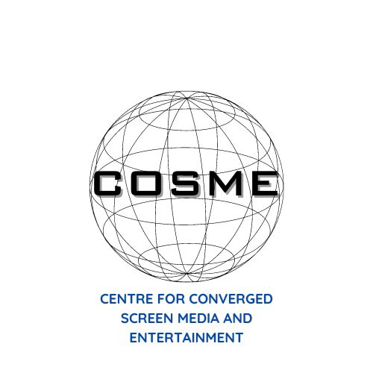

**Call for papers - Centre for Converged Screen Media and Entertainment (COSME) – 2nd Annual COSME PGR Conference – University of Liverpool – Monday 19th May 2025.**

**Keynote Speaker: Professor Diane Negra, University College Dublin**

The second **COSME PGR Conference, "Disruption, Resistance and Change in Screen Media Industries",** explores the transformations catalysed by changing audience practices and shifting cultural, social, and political dynamics. The media is in a constant state of flux; from the rise of streaming and AI to the emergence of impactful cultural movements and the ubiquity of social media, industries continue to experience profound changes that are reshaping creation, distribution and experience. These developments are challenging more conventional media forms, like traditional cinema and broadcast television, whilst also offering new spaces for both innovation and debate. Simultaneously, #hashtag social justice movements and other advocacy initiatives have incited significant change in how screen media industries engage with issues of inequality, disenfranchisement, and power by exposing restrictive bias within established screen media structures both on and off-screen. As a result, disruption, resistance, and change in the media setting have created a landscape within which the industry must continually adapt to the fluidity of an increasingly converged, data and platform-driven, culturally-conscious environment.

In this context, our conference invites abstracts from **postgraduate researchers** exploring dimensions of disruption, resistance, and change in the technological, industrial, cultural, or social spheres of media industry. Throughout this, we aim to offer a platform for postgraduate researchers to challenge existing paradigms, offer fresh perspectives and consider the trajectories of global screen media industries.

To that end, we welcome any papers that examine disruption and change in media industries - possible topics could include – but are not limited to:

* The rise of artificial intelligence and the return to analog, materiality and physical media
* The evolution of media technologies (platforms, digital media, progressions and regressions in CGI)
* The disruption of distribution (streaming, IMAX, the decline of traditional cinema)
* The influence and impact of social advocacy movements
* The changing dynamics of creative work (strikes, labour laws, industry shifts, the gig economy)
* The role of social media in reviving content and redefining audience engagement
* The shifting power dynamics between fans and their chosen media (fanon vs. canon, user generated content)
* The evolution of performance (music, screen and stardom, social media) in a digitally-driven media industry
* The impact of 'Post' sensibilities on media discourse and industry (post-feminism, post-race, post-colonial, etc.)
* Histories of media disruption, resistance and change
* Increased inclusivity in screen representations and employment practices
* The absence and the call for policy innovation in response to transformation in screen media
* The emergence of the ‘influencer’ and their content culture

COSME is an interdisciplinary centre based within the Department of Communication and Media at the University of Liverpool that examines the often-radical ways in which media convergence has impacted on-screen entertainment. Focusing on technological, cultural, industrial and economic dimensions, in collaboration with industries, institutions and individual partners, COSME aims to improve awareness of how practices are influenced by cultures of convergence. Its research work will examine this from abstract concepts of ‘pleasure’ to grounded notions of ‘industry’, and from both a contemporary and historical perspective.

**This conference will be held across one day at the University of Liverpool’s main campus on Monday 19th May - exact venue TBD.**

**A £50 Amazon Voucher will be awarded to the best paper presented on the day.**

**Abstracts should be no longer than 250 words. Please include a 50-word biography, including institutional affiliation.**

**Please email your abstracts to: cosmepgr@liverpool.ac.uk  
  
Deadline: Friday, 18th April   
  
We will notify you by Friday, 25th April if your paper has been accepted.**