University guidance on designing a participant consent form

Text with a coloured background in this document is for guidance only, and should be deleted from the final ‘Participant consent form’ that is provided to participants.

The informed consent process

The informed consent process requires that prospective participants are provided with as much information as possible about a research project in order that they and / or their legal guardians / advocates can make a truly “informed decision” about whether or not they want to take part in the project.

Consent forms should be provided to participants after they have read and had time to consider all the information on the participant information sheet. This document has been produced as guidance for staff and students designing their consent forms. If you have any questions, please contact the Research Ethics and Integrity team on 0151 794 8290 or at ethics@liverpool.ac.uk.

Guidelines for creating your participant consent forms

Designing your participant consent forms

The design of your consent form should reflect the nature of the research study. Some consent forms may therefore need to be more detailed than others; or may use graphics as well as text.

If you are planning to take verbal consent from participants, a consent script should be devised beforehand and be based on the statements made in your consent form.

If you are researching a vulnerable population or working with children, please adapt your consent forms to the appropriate language and layout.

Important rules relating to your consent forms

Consent forms should be signed and dated by the participant – or witnessed in the case of verbal assent - and name of person taking consent and stored securely for the appropriate amount of time.

Please note:

- If an amendment to a document is made, the version number and date must also be amended.
- Failure to include version dates will slow the approval process as they will be sent back to the researcher for amendment.

It is essential that any logos, project titles, contact details, etc. are consistent across all documents, and that a record of the changes to each document is logged through version numbers and dates.

You must ensure that the statements listed in your consent form are also mentioned in your participant information sheet and data management plan, and that the information is consistent across each document.

Obtaining consent in online studies

In the case of online studies involving anonymous data collection at a single time point, it is good practice to create an introductory information page where participants can read information on the study and then tick a box to indicate understanding of the information. Following this, there should be an online consent form that is consistent with your word-processed form. Each consent statement should have a tick box next to it that the participant can populate, along with an electronic signature or typed signature box. The participant should not be allowed to proceed with the study if all boxes are not ticked and there is no signature. See the screenshots on the pages below for guidance on how this may look:

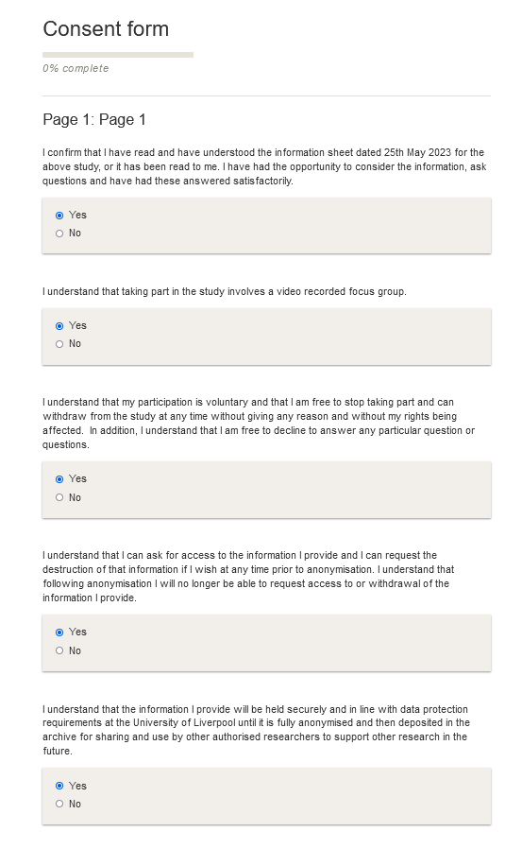
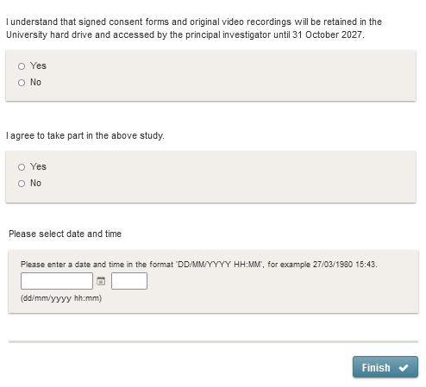

Checklist for your consent form

Before finalising your consent form using the template on the following page, please use the checklist below to ensure your consent form conforms with good research practice.

Consideration | Response
Have you worked with, consulted with, or at least considered the needs of, the research population when designing your consent forms?  (Information should be displayed in an appropriate format for the population involved in the research) | ☐
Have you considered different ways to provide information to your participants?  (For example: explanatory videos, leaflets and visual media, audio recordings, diagrams etc.) | ☐
Do your consent forms have version numbers and dates? | ☐
Is the information in your consent form consistent with information in other documentation?  (For example, have you described the data management practices consistently in your information sheet, consent form, and research ethics application?) | ☐

Please see below the University of Liverpool Consent Form template which contains mandatory statements which apply to each research project.

Editable sections are highlighted in yellow. Please delete / amend as appropriate and ensure the formatting is changed to make consistent with the rest of the form before saving.

Appendix 1 details optional statements which apply only to specific studies. The template provided on the following pages reflects the best practice in research ethics and data protection for most studies. However, for some studies it may be necessary to include additional consenting statements (for example, to obtain specific consent for transferring personal data outside the EU), or to deviate from the University template to ensure that the consent form is suitable for the study population (for example, research involving children).

University Participant consent form template
Version number & date:
Research ethics approval number:
Title of the research project:
Name of researcher(s):
Please initial box
- I confirm that I have read and have understood the information sheet dated [DATE] for the above study [or it has been read to me]. I have had the opportunity to consider the information, ask questions and have had these answered satisfactorily.

- I understand that taking part in the study involves [briefly describe how information is captured – e.g., an audio recorded interview, or a video recorded focus group].

- I understand that my participation is voluntary and that I am free to stop taking part and can withdraw from the study at any time without giving any reason and without my rights being affected. In addition, I understand that I am free to decline to answer any particular question or questions.

- I understand that I can ask for access to the information I provide, and I can request the destruction of that information if I wish at any time prior to [specified point: e.g., anonymization / publication / a time frame e.g. - 1 month]. I understand that following [specified point] I will no longer be able to request access to or withdrawal of the information I provide.

- I understand that the information I provide will be held securely and in line with data protection requirements at the University of Liverpool until it is [fully anonymised] and then deposited in the [Archive] for sharing and use by other authorised researchers to support other research in the future.

- I understand that signed consent forms and [original audio/video recordings/ questionnaires] will be retained in [specify location and who has access to data] until [specific relevant period].

- I agree to take part in the above study.
__________________________ __________ ______________________
Participant name Date Signature
__________________________ __________ ______________________
Name of person taking consent Date Signature
Principal Investigator Student Investigator
[Name] [Name]
[Work address] [Work address]
[Work telephone] [Work telephone]
[Work email] [Work email]
Accessibility: To request this document in an alternative format, please contact the Principal Investigator listed above.

Appendix 1: Optional statements (choose as appropriate)

This section provides examples of statements that may be appropriate to specific types of studies, but which will not be appropriate to all studies. Please read the sections below carefully and consider which statements are relevant to include in your study.

Situations where the participant information sheet has been read to aloud to the participant [add the following statement above the signature line]

I have accurately read out the information sheet to the potential participant and, to the best of my ability, ensured that the participant understands what they are freely consenting to.

Transferring personal data outside the EU

I agree for my personal data to be transferred outside of the EU and I have been informed of where the data will be sent and of the safeguards in place.

Open data and data sharing

I understand that the information I provide will be held securely at the University of Liverpool until it is [fully anonymised] and then deposited in the [Archive] for sharing and use by other authorised researchers to support other research in the future.

I understand that other authorised researchers may use my words in publications, reports, webpages, and other research outputs, only if they agree to preserve the confidentiality of my information.

I understand that personal information collected about me that can identify me, such as my name or where I live, will not be shared beyond the study team.

Studies recording consent electronically via a digital platform such as Qualtrics or via a mobile phone app

I declare that I have provided accurate identity details [full name and electronic signature].

Studies where data may need to be disclosed to individuals or institutions outside of the research team

I understand that data collected during the study may be seen by employees of The University of Liverpool or another regulatory authority, only where it is relevant to my involvement in this research. I give permission for these individuals to have access to my data.

Audio / video recordings

I understand and agree that my participation will be [audio recorded / video recorded] and I am aware of and consent to your use of these recordings for the following purposes: [specified purposes].

Storage of documents

I understand that signed consent forms and [original audio/video recordings/ questionnaires] will be retained in [specify location and who has access to data] until [specific relevant period].

I understand that a transcript of my interview will be retained for [specific relevant period].

Exclusion criteria

I understand that I must not take part if… [list exclusion criteria, for example pregnancy].

Risk to participants

I understand that taking part in the study has [description of risk] as a potential risk.

Affording participants the opportunity to receive a copy of the report

The information you have submitted will be published as a report; please indicate whether you would like to receive a copy.

Confidentiality of the data

I understand that my responses will be kept strictly confidential. I give permission for members of the research team to have access to my fully anonymised responses. I understand that my name will not be linked with the research materials, and I will not be identified or identifiable in the report or reports that result from the research.

I understand that confidentiality and anonymity will be maintained, and it will not be possible to identify me in any publications [Explain the possible anonymity options that you are offering participants and provide appropriate tick box options accordingly].

Disclosure of criminal activity/ Duty to disclose

I understand that the confidentiality of the information I provide will be safeguarded and will not be released without my consent unless required by law. I understand that if I disclose information which raises considerations of the safety of myself or the public, the researcher may be legally required to disclose my confidential information to the relevant authorities.

Use of quotes and fully identifiable information

I agree that my information can be quoted in research outputs such as [list research outputs].

I would like my name used and I understand and agree that what I have said or written as part of this study will be used in reports, publications, and other research outputs so that anything I have contributed to this project can be recognised.

I agree that my real name can be used for quotes.

Health-related findings in research

I agree for my GP to be contacted if any unexpected results are found in relation to my health.

Re-contacting participants for the purpose of inviting them to take part in future studies

I agree to being contacted at a later date and invited to take part in future studies. I understand that I am only agreeing to receive information and I am under no obligation to take part in any future studies. I understand that if I decide not to consent to being contacted in the future, it will not have any influence on my involvement in this particular research study [and will not affect any standard of care that I receive].

For human material projects only:

The potential benefits of storing my [sample] for future research have been explained to me and I consent to the use of my [sample] with additional, separate ethical committee approval:

I. For future similar studies

II. For future unspecified research

III. For future unspecified studies including genetic analysis* [if appropriate]

IV. For future unspecified studies including commercial research* [if appropriate]

V. For future unspecified studies including non-human models* [if appropriate]

I do not wish my [sample] to be used for any purpose other than this study.

I agree to gift my samples to the University of Liverpool, and I consent to the storage and use of my samples for future unspecified research [including genetic analysis].

I understand that I will not profit from any commercial research involving my [sample].

I agree to being contacted at a later date and invited to take part in future studies of a similar nature.

I understand that I am only agreeing to receive information and I am under no obligation to take part in any future studies. I understand that if I decide not to consent to being contacted in the future, it will not have any influence on my involvement in this particular research study [and will not affect any standard of care that I receive].

I agree to being contacted at a later date and invited to take part in future studies. I understand that I am only agreeing to receive information and I am under no obligation to take part in any future studies. I understand that if I decide not to consent to being contacted in the future it will not have any influence on my involvement in this particular research study [and will not affect any standard of care that I receive].

I understand that any samples or information given to research groups will be anonymised and my identity will be protected.

I understand that I am free to withdraw my consent and request destruction of my [sample] without giving a reason and without my medical treatment or legal rights being affected.

Appendix 2: Example participant consent forms

Examples of participant consent forms can be accessed through the following links:

- Health Research Authority
- UK Data Service

Examples of age appropriate consent forms for children can be found using the below resources:

- Health Research Authority
- Global Kids Online

University of Liverpool example of a child assent form

For the [researcher / your class teacher / your parent or guardian] to fill in:

I have witnessed ________________________________ give their verbal assent to participating in this study.

Name and occupation (researcher/teacher/parent or guardian) of witness:

_____________________________________________________________________________

Signature:____________________________________________________________________

Date:_________________________________________________________________________

Please note: for the purposes of data protection, the UK is classed as “adequate” and is free to transfer data within the EU with no additional obligations.

