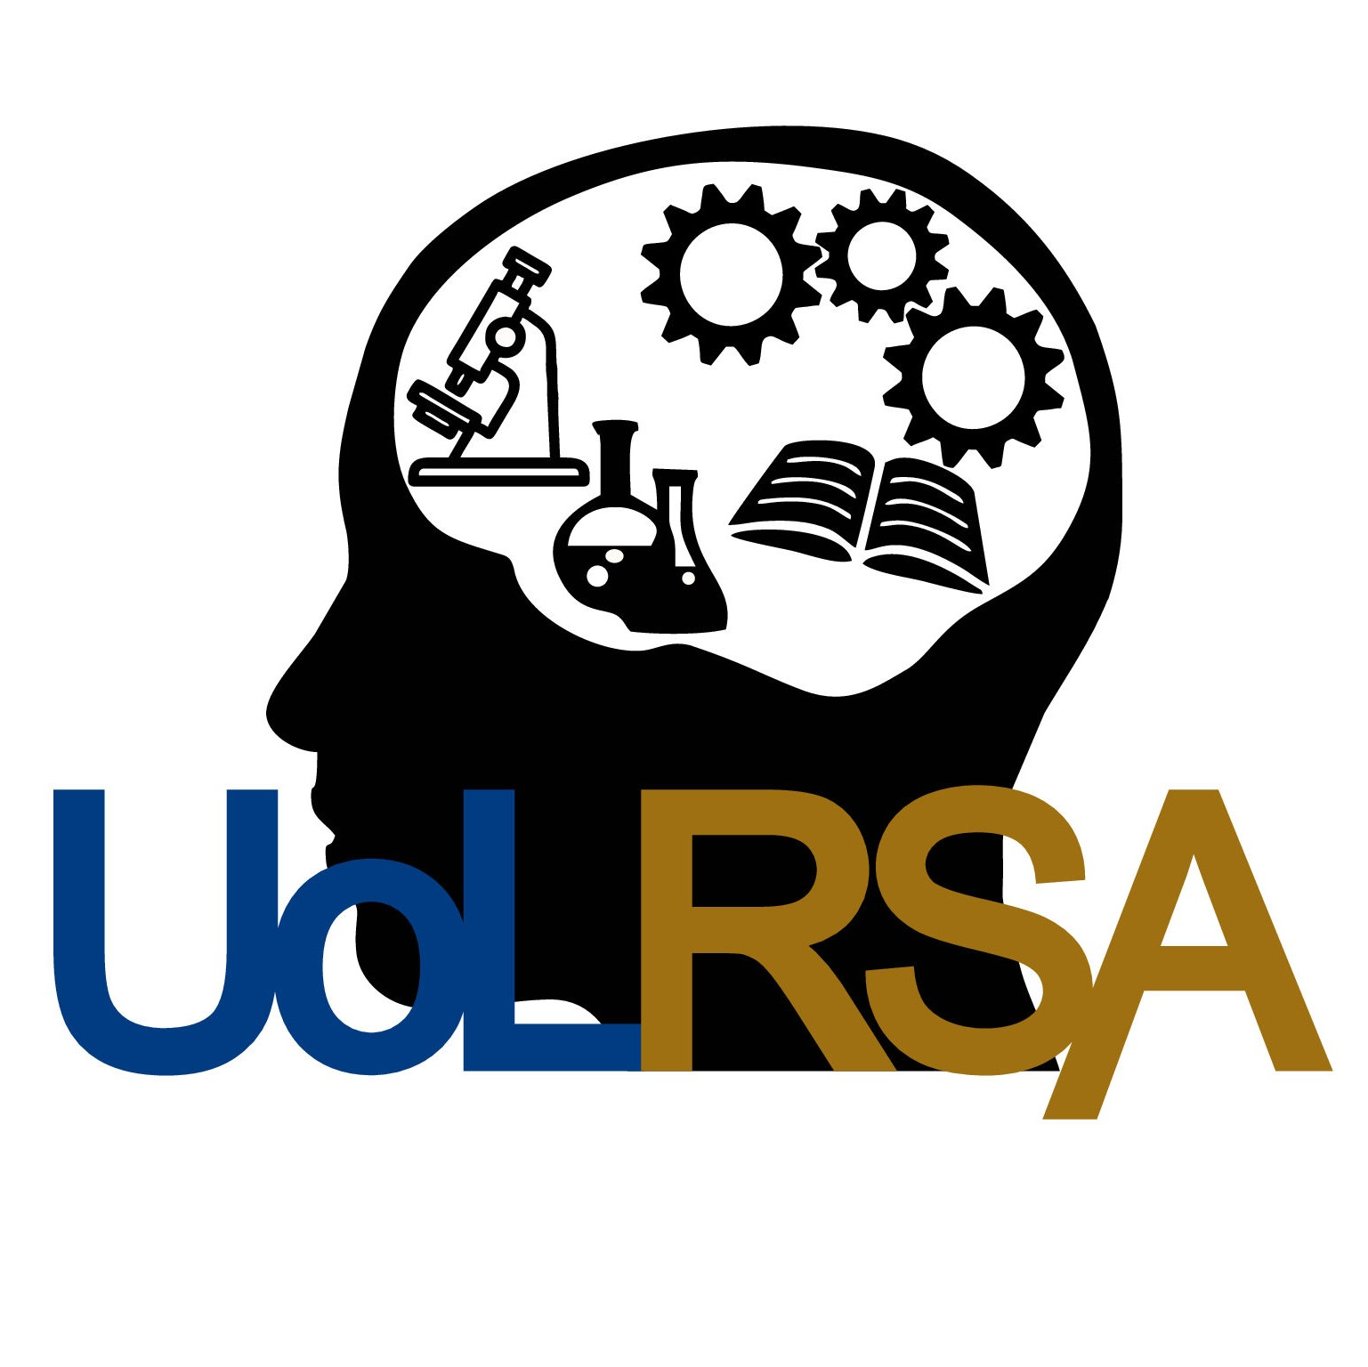
SELF-REFLECTION

Research Staff Conference 2023
What have you learned at the Research Staff Conference? | Were any of your existing views changed or challenged?  What key strengths did you uncover?  What areas of development have you missed?
Please type here
What are you going to change in the short term? | Is there anything you can do differently starting tomorrow?  What specific actions will you take to apply or follow up your learning?
Please type here
What do you hope to change in the next 3 months? | What do you hope to be doing differently in 3 months’ time?  What steps will you take to achieve them?  How can others help you reach those aims?
Please type here

Sponsored by
We thank all our generous sponsors

