HUMAN FACTORS IN INNOVATION
Authored by Caroline Broad, Broad Associates Ltd

As part of the 2023 Making an Impact programme, Dr Iain Hennessey, Clinical Director of Innovation at Alder Hey Children’s Hospital, described Innovation as:

“…a fresh idea implemented to achieve value”

That created value could be economic or societal. Innovative activity benefits from best practice in the following six areas of Human Factors. Done well and consistently, these factors contribute to successfully creating economic and/or societal value.
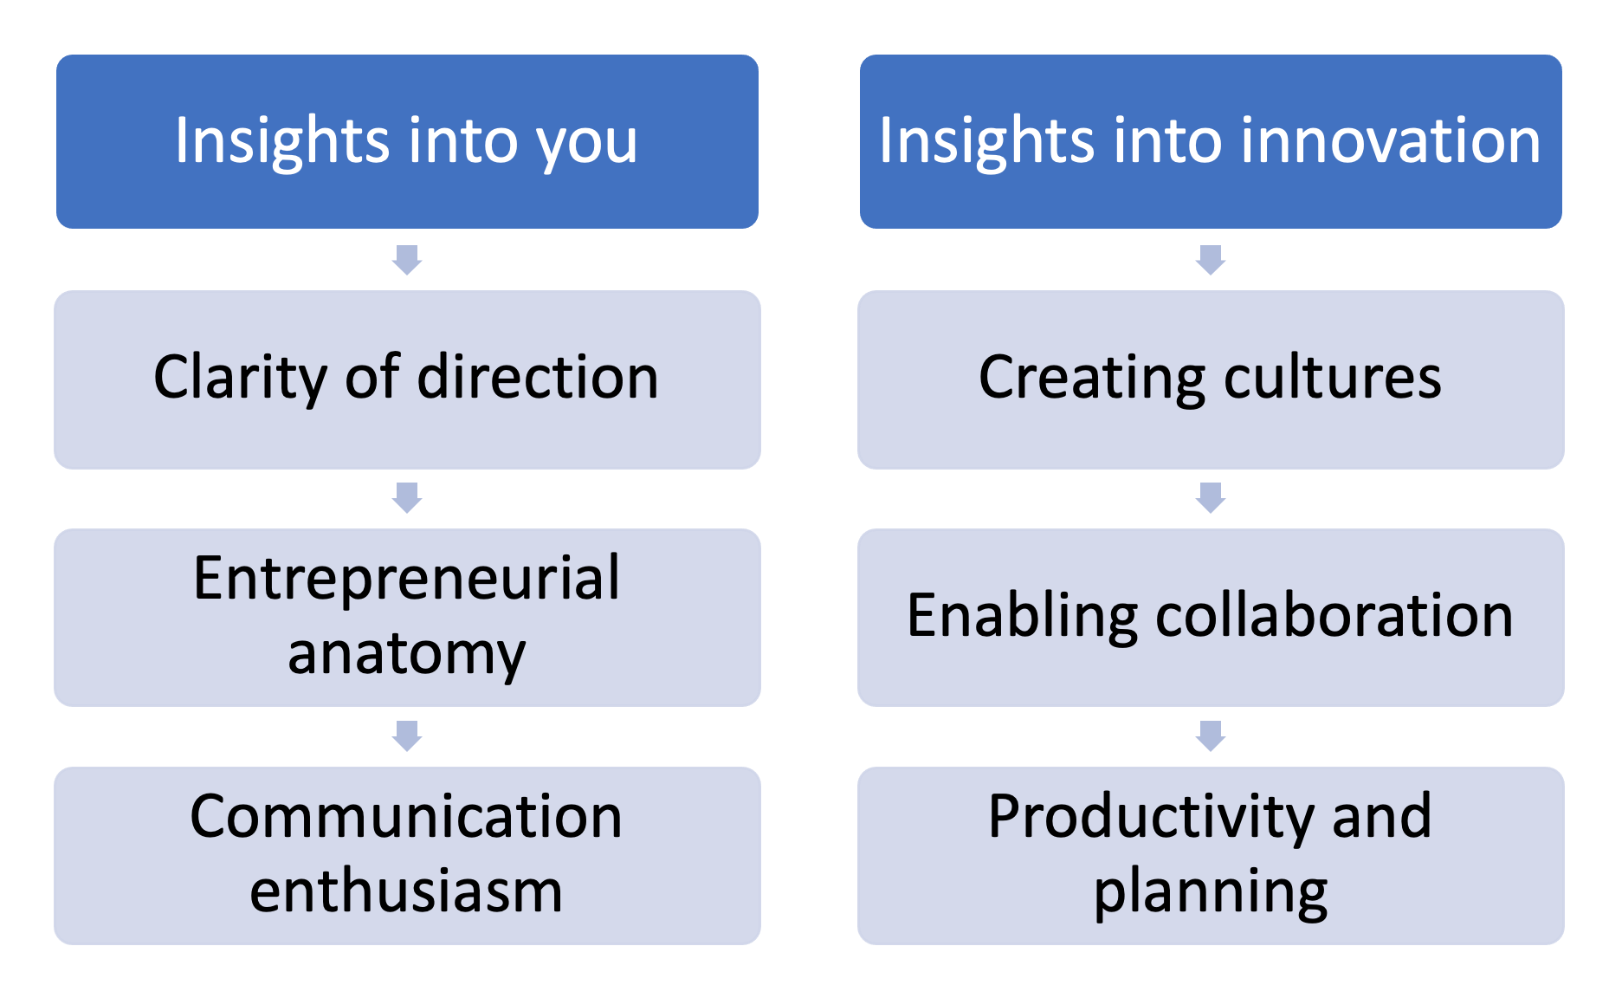
Six Human Factors in Innovation

This workbook will help raise your self-awareness on your current knowledge and strengths, and help you plan how to increase your skills and knowledge in each of the human factors. After responding to the questions in each of the six sections ask yourself: ‘what useful action can I commit to, to increase my innovative impact?’

What kind of innovative activities would benefit both your research and your professional development?
- Through collaborations with non-academic organisations perhaps? If so, Knowledge Transfer Partnerships are an interesting example and may provide inspiration
- Through involvement in spin outs or start-ups? If so, check out InnovateUK and learn more about Intellectual Property and Commercialisation from the University of Liverpool Enterprise team
- Improving current working practice or contributing to policy development?
- Perhaps by engage communities that will benefit from understanding and utilising your research?

Use your response as a context for answering the questions in this workbook.

Stakeholders are mentioned frequently in this workbook. List all your stakeholders for this innovative idea. A stakeholder is ‘An individual, group or organization who may affect, be affected by, or perceive itself to be affected by a decision, activity or outcome of the project’.

5th Edition PMBOK® Guide—Chapter 2: Stakeholders

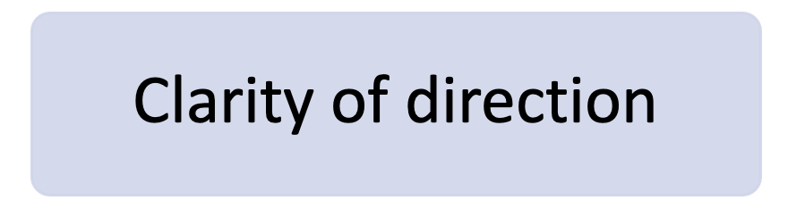

- What kind of impact do you want to create? Is it a service or a product?
- Why is it important you to create this impact?
- How will you create this impact and who will benefit?
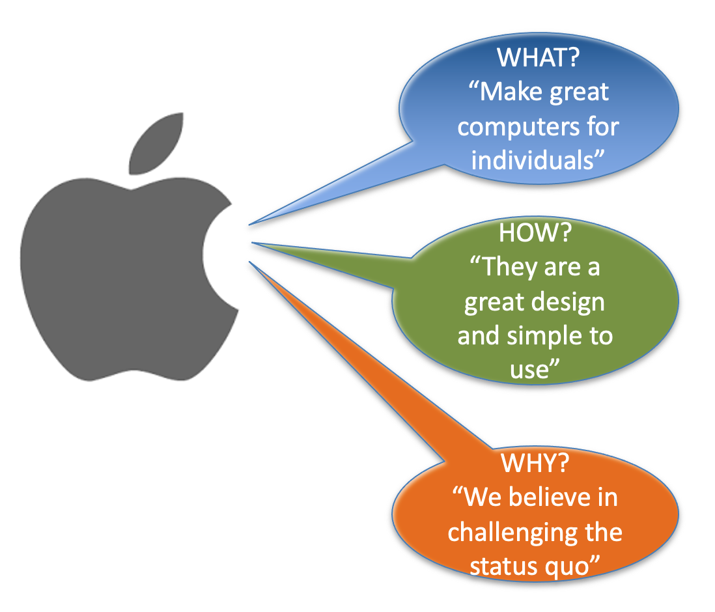
If you can clearly communicate a clarify of direction, you will be able to engage stakeholders more easily – they will better know if your idea aligns with their activities and be better informed to usefully contribute to your project.

Diagram: Apple’s original What? How? And Why?

- How confident are you that you can respond effectively to the impact of risks on a project?
- What examples do you have in your work life of your skills in overcoming challenges?

Angela Duckworth ‘focuses on two traits that predict achievement: grit and self-control. Grit is the tendency to sustain interest in and effort toward very long-term goals’ (Duckworth et al., 2007). You may want to complete her Grit Scale questionnaire.

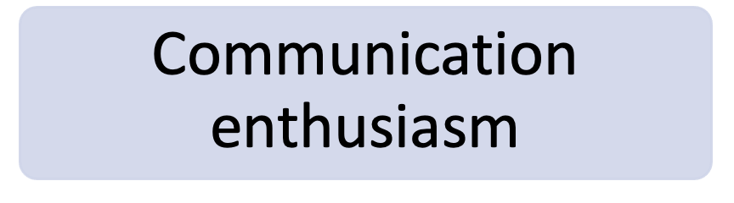

- What are your strengths when promoting your ideas online and in person?
- Where could you reach the people that you need to promote your innovative ideas to?

As an innovator, it is helpful to practice communicating your What and your Why. Share the story of what you do and why you do it to potential stakeholders. However make sure you protect the information on How you do what you do, as the how is where you will find your intellectual property (IP). Ensure you receive advice on how to appropriately protect any potential IP, and take that advice early on in any innovative project.

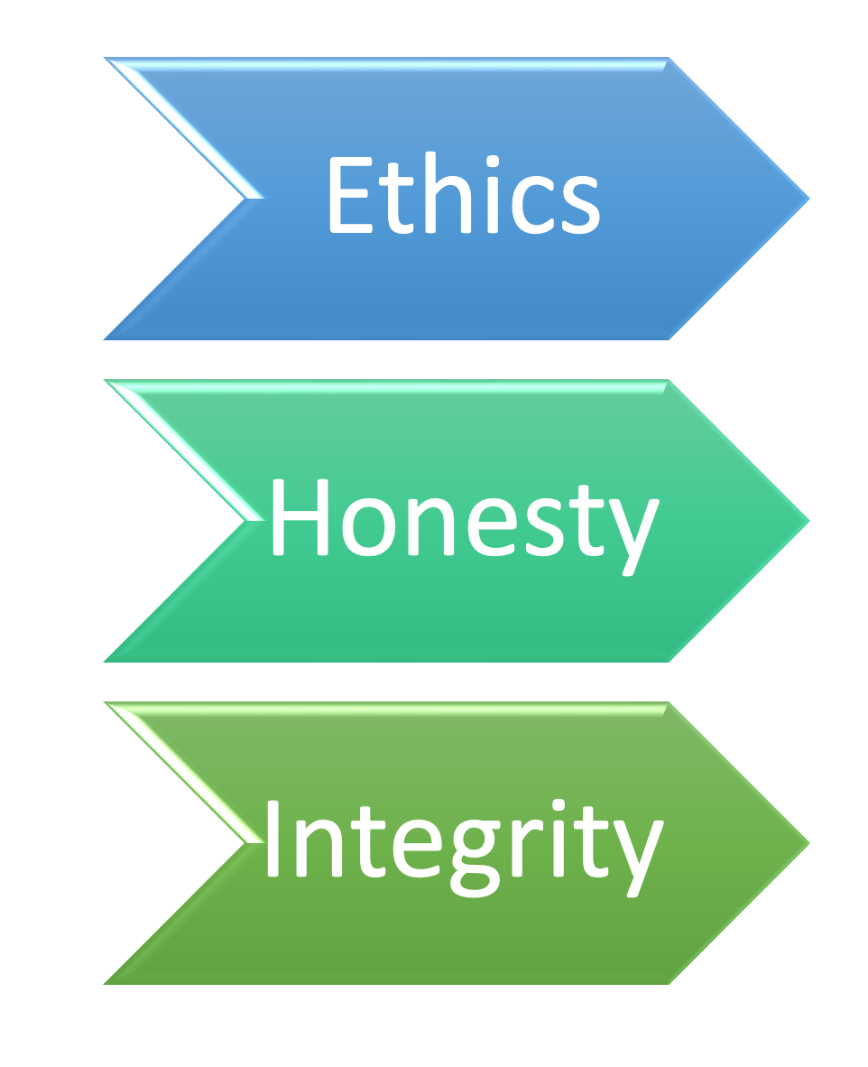
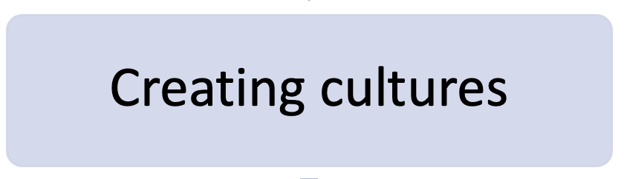

- What do you value in how people should work together?
- How do you empower others to contribute to projects?

Choose how you wish to act, commit to working in a way that will model a behaviour of innovation, creativity and respect. The Harvard Business Review is a good resource for insights into innovative ways of working

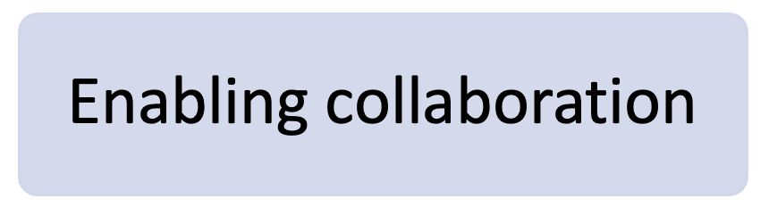

- How often do you ask questions of others to find out their perspective without providing yours? Think of some tangible examples

The key to an effective collaboration is to understand key stakeholders’ perspectives and requirements. Once you are clear on those, you can incorporate the necessary elements into your project. Good questioning and listening are a key human factor in enabling collaboration. And collaboration is key to innovation.

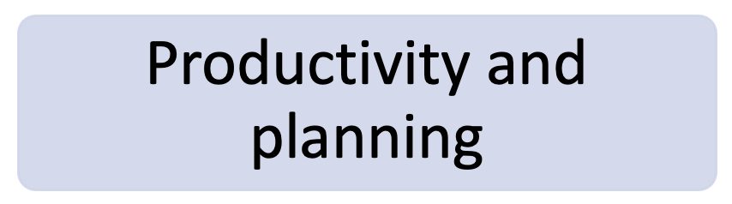

- What are your project management strengths?
- How committed are you to ensuring that any project is well managed and what resources might you need to ensure that takes place?

This final human factor is all about organisational skills. It’s about how you implement your innovations. Not just at the beginning of a project, but consistently throughout the whole project. The best practice project management in a commercial setting is using PRINCE-2. What workshops can you attend to increase your project management skills and what institutional resources are available to support the effective implementation of your innovative idea?

