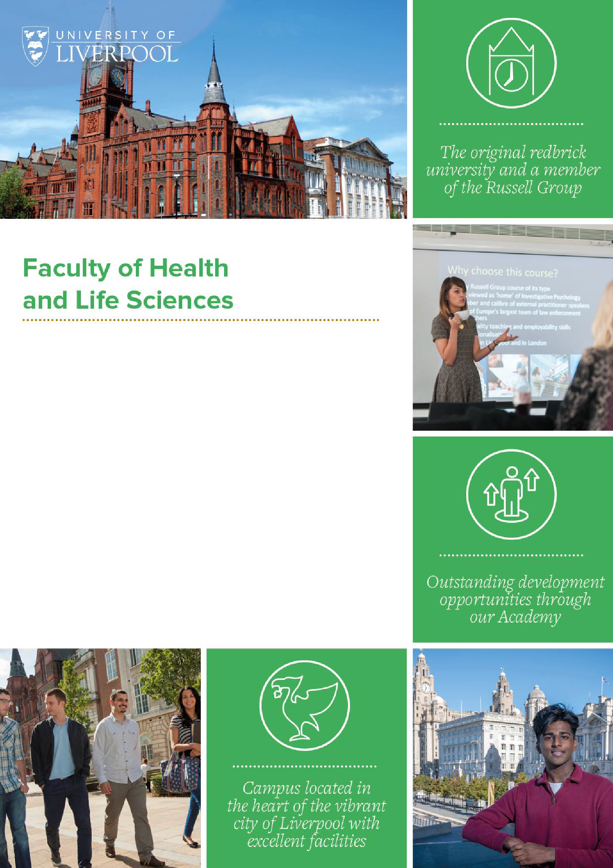

**UNIVERSITY OF LIVERPOOL TENURE-TRACK**

**CLINICAL ACADEMIC TRAINING IVENS FELLOWSHIP**

**Job Ref:**

**Location:** University Campus, local NHS trusts

**Salary:** To be determined with due regard to the transitional arrangements relating to the 2016 contract for doctors and dentists in training (if applicable). Indicative scales: 2016 scale for doctors £40,257 - £58,398 per annum (plus pay premia where eligible). Pre--2009 Clinical Lecturer Scale; £38,619 - £65,955 pa

**Working Hours:** Full Time (Part time considered)

**Tenure:** This post is permanent subject to satisfactory confirmation in appointment

*Online application> Shortlisting > Interview Process> Job Offer*

**Background**

Frances Ivens (1870-1944) qualified in the Royal Free Medical School in 1902 and was appointed in 1907 as the first woman consultant in Liverpool where she ran the gynaecology department in the Bootle Stanley Hospital. She later started clinics in her home for the babies of the poor, long before infant welfare clinics were established. She was later appointed consultant at both the Samaritan and Liverpool Maternity Hospitals.

In 1914, she was asked by the French Red Cross to run the newly formed Scottish Women’s Hospital in Royaument for the French Army. She became an expert is treating wounds complicated by gas gangrene, and was awarded the Croix de Guerre and the Legion d’Honneur for her service.

In 1926 she was elected vice president of the Liverpool Medical Institute. She married, and retired from medical practice in 1930.



In honour of a great Liverpool medic, the Faculty is delighted to announce a prestigious medical fellowship for excellent candidates looking at aCL level ,or aCL transitioning to consultant level Senior Clinical Research Fellowship. These are tenure track fellowships meaning that subject to a confirmation in appointment process (CiA, i.e. achieving clear set milestones in clinical and academic career), the successful candidates will move seamlessly into a tenured senior lecturer/consultant position. A bespoke pathway will be developed for each candidate depending on stage of career and other factors.

**Role overview and University context:**

A new clinical tenure track 4-year fellowship scheme as part of Strategy 2031 is to be launched in Jan 2024, with an initial call to close on 1st April. It is intended that 4 fellows will be recruited over two years.

The aims and objectives of this scheme are:

* to partly reverse the nation-wide decline in number of clinical academics
* to attract the best and brightest and most promising talent in clinical research to Liverpool
* to grow our excellent clinical research cohort for the benefit of patients, public, the NHS and the university

We will do this by offering academic Clinical Lecturer grade positions initially but with a guarantee that, subject to receipt of a Certificate of Completion of Training (CCT) and a successful Confirmation in Appointment (CiA) interview, a tenured position at clinical senior lecturer/honorary consultant will be offered to the successful candidates.

The picture illustrates what is currently our standard pathway for aCLs, and then offers examples of how a bespoke pathway might be set up for suitable candidates.

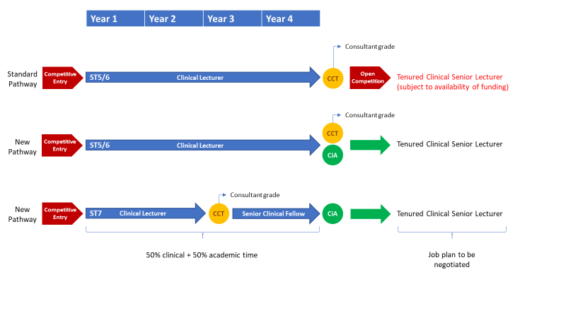

To be appointed, candidates will be required to demonstrate their potential to become the next generation of brilliant clinical research leaders. Successful candidates will demonstrate an ability to win funding for clinical research in a relevant area, in order to deliver publications and public health impact.

Whilst we anticipate that the majority of successful applicants will enter the Clinical Lecturer post as ST5/6, we aim to be as flexible as possible in our support of outstanding candidates.

The Confirmation in Appointment process will consider both clinical and academic progress and will be undertaken by the University and the supporting /appointing NHS Trust. The timing of this CiA process will be flexible. For example, post-holders who achieve CCT before the end of their 4-year ACL post will move to consultant level salary and be given the title of Senior Clinical Research Fellow for the remaining time before entering the CiA process for confirmation as a tenured Clinical Senior Lecturer.

The positions will be accredited as NIHR ACLs with access to the NIHR Academy for training, networking etc.

The specialty in which the candidates wish to work will need to be aligned broadly to UoL strengths: but otherwise, recruitment will not be focused on specific disciplinary areas.

There will be a centrally funded start-up package of £10K per annum for wet lab research; £5K per annum for all other research. Departments can also locally negotiate and fund bespoke packages for each Fellow, over and above the centrally funded provision. In addition, there are a number of internally managed translational research pump priming opportunities and externally funded (e.g. Academy of Medical Sciences Starter Grant for ACLs) that Fellows will be encouraged to access.

The positions will be funded by the UoL and by local NHS partners and will be based at the University of Liverpool and its major partner NHS Trusts or Agencies.

The role (both at ACL and at consultant-level up to the time of CiA) will require the trainees spending 50% of their time undergoing academic training combined with clinical training/delivery in the remaining 50%.

The candidate will be encouraged to apply for a further, peer-reviewed externally funded senior training award (such as a MRC Clinician Scientist Award, NIHR Advanced Fellowship, Wellcome Early Career Award). Candidates who go on to be awarded one of these prestigious and highly competitive national awards will be automatically confirmed in appointment.

At the heart of recruitment and support provided throughout the scheme, this process will emphasise research excellence and inclusive leadership potential, and the principles of Equality, Diversity and Inclusion – aiming for equity of access for all candidates with the potential to become the next generation of research leaders. Candidates interested in part time working may apply.

**The University of Liverpool Integrated Academic Training Partnership**

Our IAT partnership comprises the University of Liverpool (UoL), NHS England North West (NHSE-NW) and 8 NHS Teaching Trusts: Liverpool University Hospitals, Alder Hey Children’s Hospital, Liverpool Women’s Hospital, Clatterbridge Cancer Centre, Liverpool Heart and Chest Hospital, Walton Centre, MerseyCare and Mersey & West Lancashire. The Clinical Directorate in the Faculty of Health and Life Sciences (FHLS) at UoL manage the IAT Programme (<https://www.liverpool.ac.uk/integrated-clinical-academic-training>).

On recruitment, trainees assess their needs with their mentors and agree a training plan, including mutually agreeable supervisory arrangements. Supervisors are mandated to meet trainees formally at least once a month, but typically meet much more frequently.

We are flexible to the trainee needs, for example CLs’ time commitments range from 2/3 days a week to 6-month blocks and can be varied at-need, in discussion with the relevant Training Programme Director. Requirement for specialist clinical competencies. The Director of Clinical Academic Development (DCAD) reviews the delivery of these and resolves any challenges between Training Programme Directors, Clinical and Academic leads and trainees.

Formal quality assurance for all trainees is through mandatory annual face to face review between the trainee, the DCAD and other senior academics (but not the supervisor/s). These reviews feed into the Annual Review of Competency Progression (ARCP) and summaries are shared with supervisors, programme leads and NHSE-NW. This encourages development and progression, and enables us to identify areas of concerns early in training.

We are particularly proud of our work to create networking and mentoring arrangements that foster vertical interactions through the medical hierarchy, and of our inclusive, flexible approach to meeting our trainees’ needs.

The DCAD has an “open-door” policy for confidential queries or concerns over any aspect of the trainees’ experiences, whether scientific and academic, or work-life balance and wellbeing issues. Proactive support from the DCAD has enabled timely resolution of a number of trainee challenges faced, before ‘solvable challenges’ became ‘insoluble problems’.

NHS England North West is the Deanery responsible for all Mersey and Manchester trainees and is responsible for ensuring the quality of the clinical training for all trainee doctors across the North West, including those appointed to academic training programmes. ARCPs and meetings of the Specialist Training Committee are organised by the Deanery.

**The University of Liverpool Research Environment**

The Faculty of Health and Life Sciences (FHLS) comprises 4 Institutes: Institute of Infection, Veterinary and Ecological Science; Institute of Life Course and Medical Science; Institute of Population Health; Institute of Systems, Molecular and Integrative Biology. The Institutes enhance interdisciplinary collaboration, help to integrate research activities and create critical mass, focused on areas of research with high impact.

FHLS has over 900 academics, 100 clinically active. The recent Research Excellence Framework exercise showed that 91% (UoA1) to 97% (UoA2) of our research is world-leading and internationally excellent with excellent impact. We received in excess of £80M research income in 2021-22.

Our major research areas aligned with NIHR themes are digital health, public and population health, clinical pharmacology and therapeutics, multiple long-term conditions and mental health. Other priorities are infectious disease, healthy lifespan (including maternal and child health as well as chronic conditions) and cancer.

FHLS has extensive facilities which our IAT programme supports trainees to access:

* Liverpool Shared Research Facilities (LIV-SRF) offers flexible access to world-class equipment, expertise and academic support for life and clinical sciences from bioimaging through to multi-omics.
* Liverpool Clinical Trials Centre, part of the NIHR Research Support Service, and MRC/NIHR Trials Methodology Research Partnership supports research methodology and statistics.
* NIHR-funded Liverpool Reviews & Implementation Group share expertise in health economics and systematic reviews.
* Data science and qualitative methods expertise is available from the Institute of Population Health and NIHR Applied Research Collaboration North West Coast (ARC NWC).
* Regulatory, biobanking, study design and PPIE support is led from the Clinical Directorate.
* Discovery, development and testing of new treatments e.g. through the Liverpool Experimental Cancer Medicines Centre, and adult and paediatric NIHR clinical research facilities (CRF)

**The Liverpool Clinical Environment**

Our trainees are embedded in diverse clinical environments:

* Liverpool University Hospitals NHS Foundation Trust, 11th largest in the country, providing acute and specialist care and hosting an adult CRF (renewed for £5.5m in 2022 and also supporting early phase studies in local specialist hospitals), the only NIHR CRF with MHRA accreditation.
* Four Specialist Trusts providing local, regional and national specialist care for adults: Walton Centre NHS Foundation Trust (University Hospital status); Liverpool Women’s NHS Foundation Trust; Liverpool Heart and Chest Hospital NHS Foundation Trust; Clatterbridge Cancer Centre NHS Foundation Trust
* Alder Hey Children’s NHS Foundation Trust (University Hospital status) providing specialist paediatric care and hosting one of only two NIHR-funded CRF’s for children
* Merseycare, the largest UK mental and community health trust Liverpool City Council for Public Health and Primary care

The Clinical Directorate and DCAD actively engage with Research and Medical Directors of all Trusts to ensure that the academic environment for trainees is supportive. Engagement is through formal meetings and regular dialogue, and considers research support, protection of research time for trainees, and clinical and academic career progression. This ensures NHS trusts and clinicians have a clear understanding of the commitments made to and by the trainees.

**Confirmation in Appointment**

**To have tenure confirmed, Fellows will be required to demonstrate that they have achieved the following requirements.**

**Research**

* Fulfilled the agreed plans and priorities for their research programme, including generation of scientific outputs. funding, and impact to an internationally excellent standard, or be able to demonstrate that their research is progressing towards an internationally excellent standard.

**Learning and Teaching**

* Fulfilled the agreed teaching expectations to a standard expected in their subject area – this may include contributions to UG/PG tutorials, lectures, workshops and research projects. The degree of involvement in teaching will be phased in over the course of the fellowship.
* Contributed to the student experience at undergraduate and/or postgraduate level, including evidence of PGR supervision where appropriate
* Achieved an appropriate teaching qualification e.g. ULTRA

**Knowledge Exchange**

* Awareness of and engagement with the internal and external knowledge exchange environment, with a clear plan for continued knowledge exchange activity

**Contribution and Engagement**

* Awareness of and alignment with the University’s plans and priorities
* Successfully fulfilled the agreed leadership and managerial activities assigned to them
* Contribution and engagement with departmental/institutional plans and priorities
* A clear longer-term career plan
* Carried out their duties in line with University values

**Development**

Fulfilled any required development and that they have an ongoing plan for the development of their career

## In addition to the above, all University of Liverpool staff are required to:

* Adhere to all University policies and procedures, completing all obligatory training and induction modules, including Equality & Diversity and Health & Safety.
* Respect confidentiality: all confidential information should be kept in confidence and not released to unauthorised persons.
* Participate in the University’s Professional Development Review scheme and take a proactive approach to own professional development.
* Demonstrate customer service excellence in dealing with all stakeholders.
* Embody and uphold the University’s Vision and Values.

|  |  |  |
| --- | --- | --- |
| **Essential Criteria** | | **Desirable Criteria** |
| **Experience** | | |
| 1.1 | Evidence of achievement of Foundation  competencies or equivalent |  |
| 1.2 | In possession of MRCP, FRCS or equivalent appropriate to stage of career and in specialty  training or eligible to join specialty training |  |
| 1.3 | Evidence of good progress in clinical training and that completion of specialty training may be accommodated either during or shortly after the 4-year period of the CL award |  |
| 1.4 | Experience of successfully communicating and presenting research findings to diverse audiences and stakeholders |  |
| 1.5 | Track record of producing high impact research and/or innovation outputs that stand out in the field |  |
| 1.6 | Demonstrable potential to apply for competitive external research funding and awards |  |
| **Education, Qualifications and Training** | | |
| 2.1 | Submission for a higher degree (PhD or equivalent) in a relevant subject area  (NB must be awarded before taking up contract) | Awarded a higher degree (PhD or equivalent) in a  relevant subject area |
| 2.2 | Evidence of commitment to specialty | Intercalated honours degree and/or additional  qualifications e.g. MSc etc. |
| **Skills, General and Special Knowledge** | | |
| 3.1 | Excellent disciplinary knowledge and a compelling vision for the excellence and importance of your proposed area of research | Knowledge and skills in clinical trials and research methodology |
| 3.2 | Demonstration of acquisition of the level of knowledge and skills necessary for the achievement of Foundation and clinical (matched to the entry level) competencies or  equivalent | Knowledge and skills in clinical trials and research methodology |
| 3.3 | Demonstrable potential to lead and develop a team, or taking a leading role in a relevant field |  |
| 3.4 | Evidence of success in leading publication of excellent research | Evidence of success in making your research have impact on patients, healthcare, NHS or economy |

|  |  |  |
| --- | --- | --- |
| **Personal Attributes and Circumstances** | | |
| 4.1 | Evidence of team working skills |  |
| 4.2 | Evidence of leadership potential |  |
| 4.3 | Indication of medium and long-term career  goals |  |
|  |  |  |

# "Our vision is to be a connected, global University at the forefront of knowledge leadership." Vice-Chancellor, Professor Tim Jones

Established in 1881, we are an internationally renowned Russell Group university recognised for our high- quality teaching and research. We are consistently ranked as one of the best universities both nationally and globally, and the majority of our research is rated world leading or internationally excellent. Find out more here.

## Our Areas

When you work at the University of Liverpool you are more than just your job role. You are a crucial part of our mission to improve lives on a local, national and international scale. Click on the relevant link(s) below for more information on the area you will be working in.

## Why Work Here

We recognise, appreciate and celebrate the incredible work our staff do every day. As well as generous terms and conditions, we offer a range of enviable benefits and provide support for colleague’s wellbeing and development. Discover more here.

## Moving from abroad

As a global institute, we welcome applicants from all nationalities, moving from a different country can be challenging and we would like to help as much as we can, we have put together some information on eligibility to work documentation, accommodation, schools, healthcare, life in Liverpool and the UK as well as other practical information. Discover more here.

**Our Staff**

Whether it be their friendly colleagues, supportive managers or our outstanding facilities, our staff can explain better than anyone what it is like to work for us and why they enjoy their role. See what they have to say here.

# The University of Liverpool is committed to being an inclusive employer. We welcome applications from everyone regardless of age, gender, ethnicity, sexual orientation, faith or disability.

## Contacting us

Shortlisting and interview arrangements are the responsibility of the Clinical Directorate. Informal enquiries to [ClinicalDirectorate@liverpool.ac.uk](mailto:ClinicalDirectorate@liverpool.ac.uk).

## Application process

Our e-recruitment system enables you to register for an online account, where you can view, copy and edit your applications. Set up your account here.]

Once you submit your application you will receive an automatic email acknowledgment. You can view your application at any time by clicking into the application history section of your account.

## Job description

After the closing date this job description will be removed from our website. Should you wish to refer to this information at a later date please ensure you save a copy of this document.

## Right to work

We have a legal responsibility to ensure that you have the right to work in the UK before you can start working for us. If you do not have the right to work in the UK already, any offer of employment we make to you will be conditional upon you gaining it. The UKVI have an interactive tool allowing you to immediately see if vacancies are eligible for a Skilled Worker visa. You will need to know the SOC code for the role, our most used SOC codes can be found here, if none of these apply to this role, there are more codes on the eligibility checker. The skilled worker eligibility checker can be found on GOV.UK.

## Disabilities and alternative formats

If you have any other requirements which will help you access the application or interview process or employment opportunities at the University, or if you require copies documentation in alternative formats, please email: [jobs@liverpool.ac.uk](mailto:jobs@liverpool.ac.uk) or telephone 0151 794 6771.

## Outcome of your application

The recruiting department will endeavour to respond to each application. However, if you have not heard within six weeks of the closing date, please take it that your application has not been successful on this occasion.



