**University of Liverpool**

**Contact Details**:

ELC Admissions

Student Recruitment, Admissions and Widening Participation

University of Liverpool

Foundation Building

Liverpool

L69 7ZX

United Kingdom

**Telephone**: +44 (0) 151 794 5931

**E-mail**: [elc-admissions@liverpool.ac.uk](mailto:elc-admissions@liverpool.ac.uk)

[www.liverpool.ac.uk/english-language-centre/pre-sessional-english-courses](http://www.liverpool.ac.uk/english-language-centre/pre-sessional-english-courses)

Thank you for your interest in our Pre-sessional English for Academic Purposes (EAP) Courses at the University of Liverpool.

These notes are intended to help you complete the University’s online application form and to ensure that, once completed, your application is processed as efficiently as possible.

Contained within this pack is everything you will need to submit your application to us. It includes:

* Guidance on how to complete your online application through the Apply Yourself (AY) system
* Pre-sessional English for Academic Purposes (EAP) Course Terms and Conditions which you should read carefully before submitting your application

**English for Academic Purposes is abbreviated to EAP throughout this document.**

# **Making an Online Application for an EAP course**

The online application form for EAP courses can be accessed from the main [University](https://www.gov.uk/government/publications/guidance-on-applying-for-uk-visa-approved-english-language-tests) homepage by typing **Pre-sessional English** into the **Search** box as highlighted below:

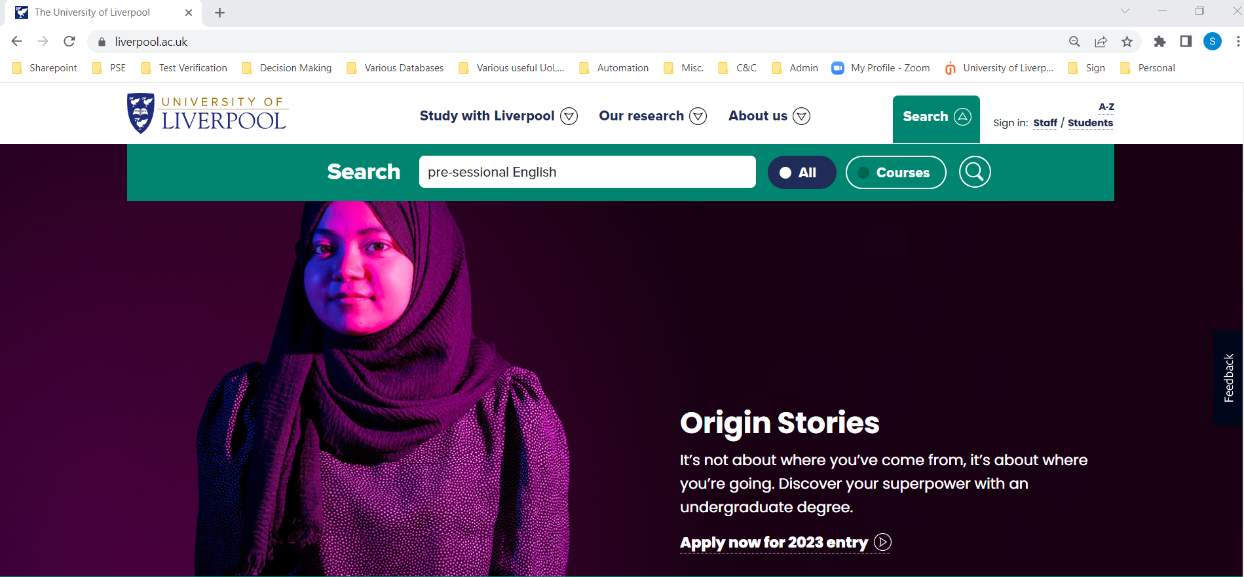

Select **English Language Centre** from the list on the left on the next screen:

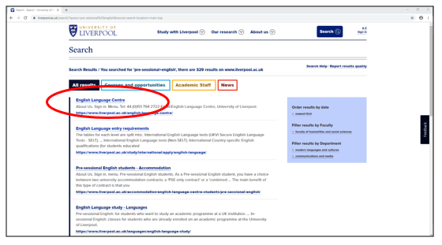

Next select **Pre-sessional English** from the list that appears:

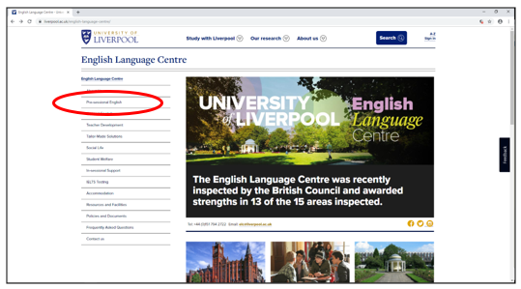

Finally, select **Apply Now** on the right-hand side of the screen:

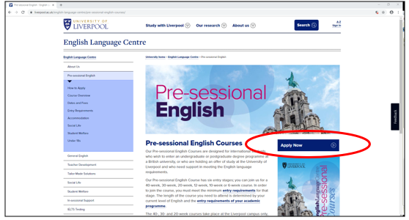

To begin a new online application, either select **Create Account\*** or **User Login** (if you have previously applied to University of Liverpool):

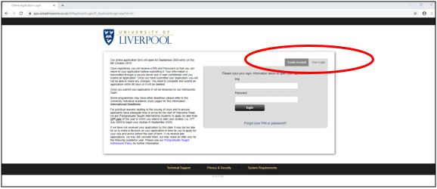

***\*Go to page 5 for guidance on creating a new Account or page 6 if you already have a User Account***

Please ensure you have any supporting documents ready to be uploaded prior to starting your Pre-sessional EAP application. Documents that should be submitted using the online form are listed below:

* Copy of scan of a valid passport
* A valid English Language Qualification Certificate (must be a valid SELT as defined by [UKVI guidance](http://www.liverpool.ac.uk/english-language-centre/pre-sessional-english-courses)) (Other tests may be accepted for online-only courses.)
* Financial Guarantee letter (if applicable). Financial guarantees must be valid and be dated within 12 months of the Pre-sessional EAP application date
* Any current or previous UK visas you may have held
* Proof that you have made an application for academic study (Undergraduate, Postgraduate, PhD). If you have applied to University of Liverpool we can check this on our system. If it is an external institution you will need to upload evidence.

# **Creating a New Account**

If you have not already submitted an application, click on **Create Account** in top right-hand corner and the box below will appear.

Firstly, you will need to set up an account profile, including your **Name**, your **Email Address**, your **Date of Birth** and your **ZIP or Postal Code**. Enter 00000 if you do not know or do not have a ZIP/Postal Code.

You will also need to create a password:

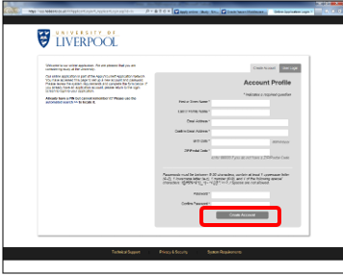

Once the profile is complete, click **Create Account**.

A confirmation message will appear when you create a new account. This includes details of the terms and conditions:

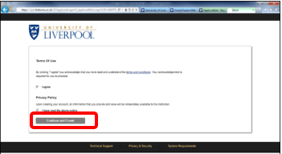

You must agree to the terms and conditions and tick both of the boxes below in order to proceed with a new application. Click **Continue and Create.**

An automatic email is then sent to the email address noted. This contains the account information, including your **PIN number**. You will require your **PIN number** and **Password** to log back into an application so you must keep this information safe.

Click **Login** to continue.

# **Already have a User Account**

If you have already created an online account when previously applying for an academic programme, enter your **PIN Number** and **Password** and click **login** to go to the home screen. The online application home form screen will now appear which lists any applications you have already submitted for academic programmes.

To start a new Pre-sessional application, click **START APPLICATION** in the Pre-sessional English Application section:

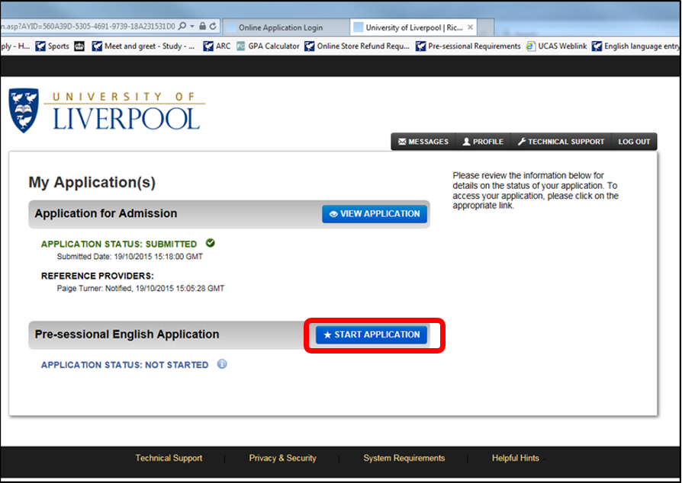

# **Completing the form**

From the main menu, click **START APPLICATION**.

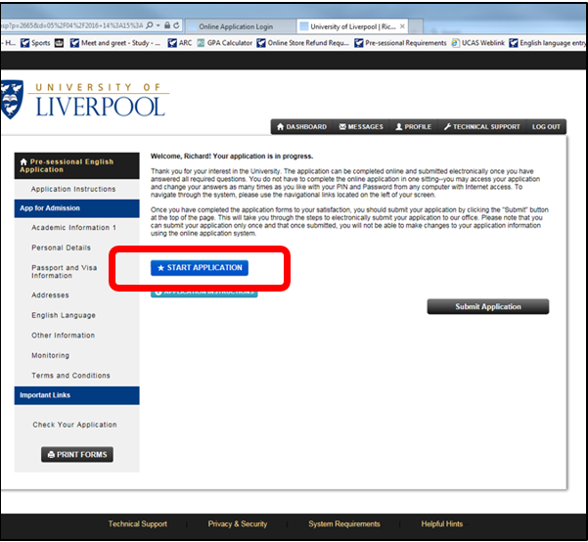

## Personal Details

This section asks for your personal information including **Name, Date of Birth** and **Gender**. Your Date of birth should be entered in the following format – Date/Month/Year e.g. 01/05/1992.

* Select the appropriate information from the drop-down menus.
* Educational Representatives submitting applications on behalf of their clients must answer **Yes** to the question highlighted below. You will be asked for more details about your Agency in a later section.
* Click **Save & Continue** to move to the next section.

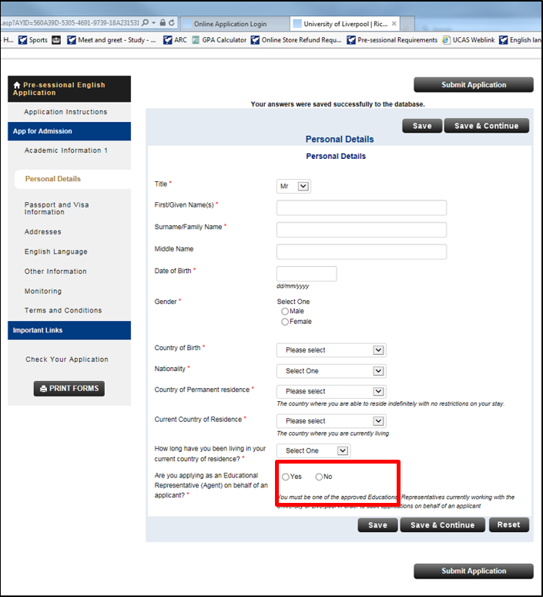

## Academic Information 1

This section is for you to select which Pre-sessional course you wish to study. You **MUST** complete the fields in the order in which they appear in the section, as each answer you provide will populate the available options in the next field.

* Select the **Admission Term** from the drop-down menu. This is the academic year in which you wish to study the Pre-sessional course. The Pre-sessional courses run in the academic term prior to your academic programme i.e. if you want to study an academic programme that starts in September 2023 (2023/24 entry), the Pre-sessional course will begin in the academic term prior to this (2022/23 entry).
* Select the **Course of Study** that you wish to apply for from the drop-down list. If you are applying for a 20, 12, 10 or 6 week course and intend to progress on to an academic programme in the Management School, you must select Management Studies Pathway.
* We need to know you have applied for an academic programme, before we can process your pre-sessional application, so please enter the **full name of the degree programme** you have applied for. E.g. MSc International Business.
* You need to inform us of the **English language requirement** of your chosen degree programme. Please select the correct requirement from the drop-down menu.
* If you have already made an application to study at the University of Liverpool (for an Undergraduate, Postgraduate or PhD programme), select **Yes** to the question and be sure to include your student reference number in the box. It is important that you enter your student reference because it will help our Admissions Team match your applications. This information is also needed so the Admissions Team know which academic programme and department you intend to study in.

If you have made an application to study an academic programme (undergraduate, postgraduate, PhD) at another institution, you will need to upload evidence of this application or evidence of an acceptance letter. Without this information your application cannot be processed.

* Click **Save & Continue** at the bottom of the page to save your information so far and to continue to the next page of the application form

## Passport and Visa Information

For International students it is very important that the correct information is provided in this section. If you are successful in securing a place on a Pre-sessional course, the details provided will be used to generate a CAS in order to apply for your Student Visa.

* Passport details required are **Passport Number**, **Expiry Date** and **Country of Issue.**

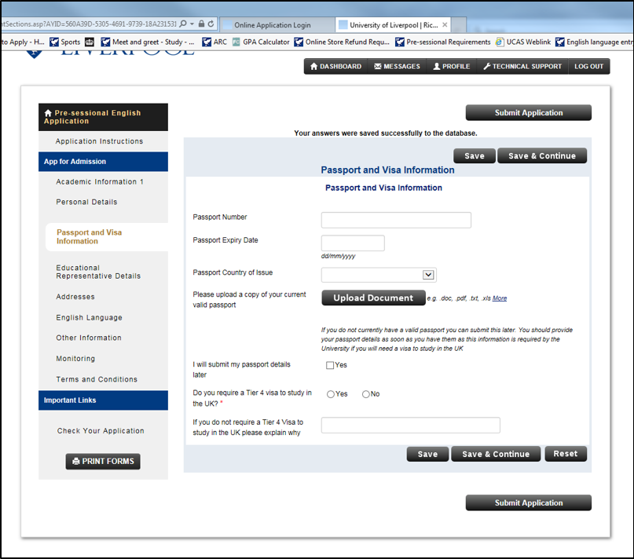

If available at the point of application, please upload a copy of the passport by clicking on **Upload Document.** A separate box will appear as below.

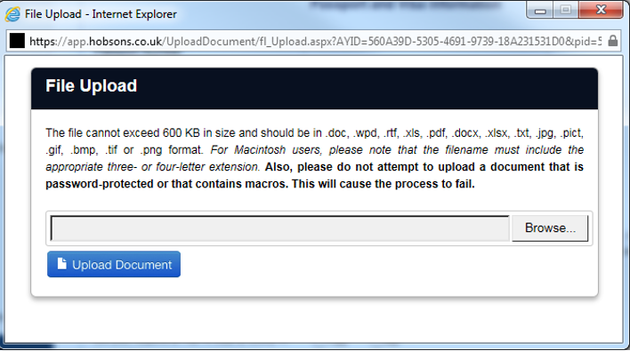

**Please note that only one file can be uploaded in this section**, therefore if you are providing more than one document, e.g. Passport and Previous Student Visa, then these should be compiled into one file prior to uploading.

If you do not have a current valid passport, you can provide us with these details at a later date by email to [elc-admissions@liverpool.ac.uk](mailto:elc-admissions@liverpool.ac.uk). We cannot issue your Confirmation of Acceptance of Study (CAS) statement without a valid passport.

* If you require a visa to study in the UK then select **Yes** as highlighted below. Most non-UK students will require a Student Visa.
* If a Student Visa is not required then please provide details of why this is the case

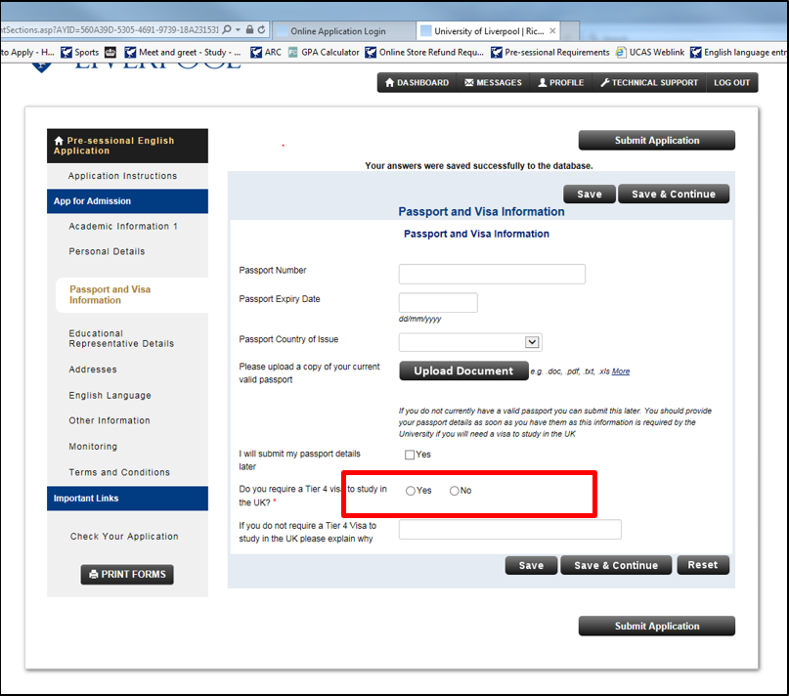

## Visa Details

We are required by UK Visas and Immigration (UKVI) to determine if there has been any previous study in the UK on a Student Visa, as this can affect eligibility for obtaining a further visa. You must declare it within this section if you have previously studied within the UK.

* Answer **Yes** or **No** as appropriate to the question highlighted below. Please provide Issue and Expiry dates of any previous Student Visa.

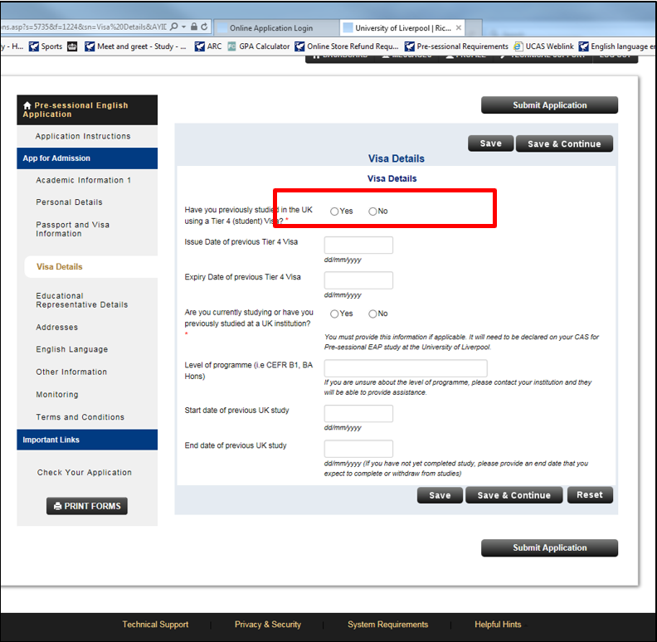

* If you are currently studying in the UK or have previously studied in the UK, please answer **Yes** to the question. Enter the level of the programme and the start and end dates of the programme. If you have not yet finished the programme, please enter the expected end date.
* You will be emailed a questionnaire to complete if you declare previous UK study within your application. We will not be able to make a decision on your application until this is returned. There will be implications with your CAS and visa application if you do not highlight this information to us on your application form.
* If you do not know the level of your programme then you must seek this information from your current institution.

## Educational Representative Details

If you are represented by an Educational Representative (agent) registered by the University of Liverpool, in this section you will be asked to provide details about the Agency you are applying from, including **Agency Name**, **Country**, **Email Address** and a unique **Agency Code**.

All of our registered Agents will have been sent their unique Agency code by the University. The code consists of 4 characters and is entered in the box below. Please enter the code in UPPER CASE e.g. AP1N.

* Click **Save & Continue** to move to the next section.

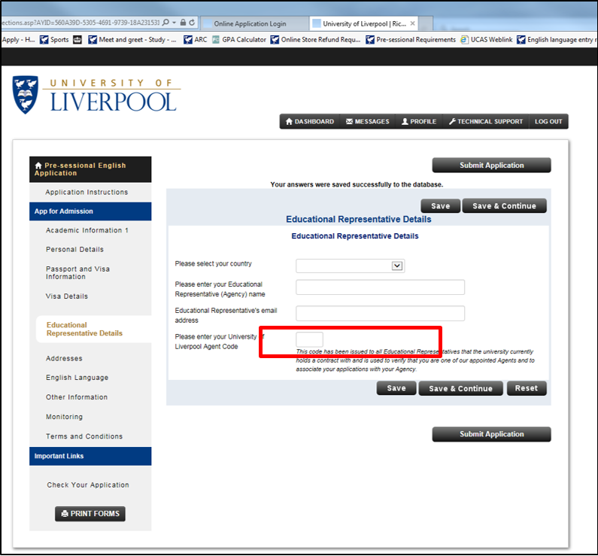

## Addresses

It is important that any addresses provided in this section are accurate and up to date.

## Permanent Address

This should be entered as your permanent home address. This address will be used on any offer letters issued.

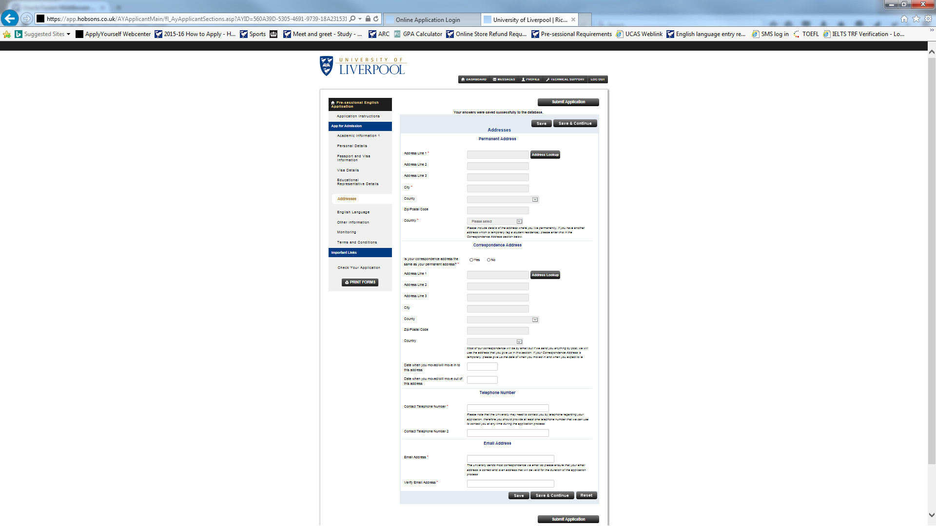

* Click on **Address Lookup** and a new window will appear as below.

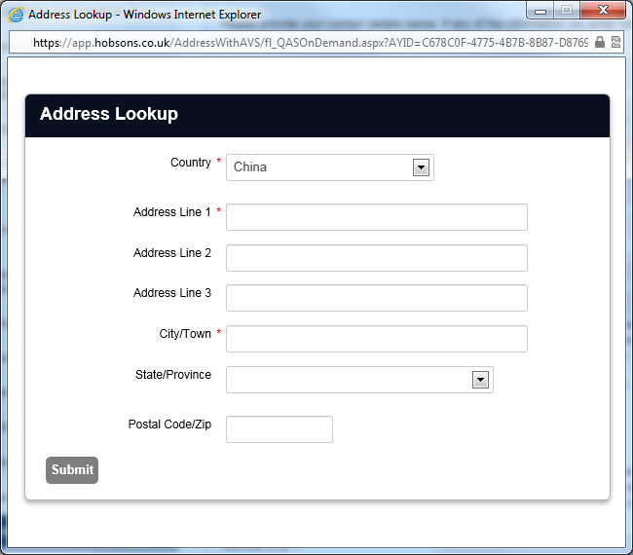

* Complete the required information and click **Submit.**

## Correspondence Address

* This should be entered as your Correspondence Address.
* If this is the same as the Personal Address, then answer **Yes** to the first question.
* Please do not enter the address of your agency as this will automatically be recorded on our system when you enter your agency code.

## Telephone Number

* This should be entered as your personal telephone number.

## Email Address

* This should be entered as your **personal** email address. If you fail to submit a personal email address then this will prevent you from receiving important information about your application and registration at the University of Liverpool.
* If represented by a recognised agent, we will always communicate directly with your agent about your application but we still require a personal email address for individual applicants.
* Click **Save & Continue** to move to the next section.

## English Language Test Certificates

To be considered for a place on a Pre-sessional English course, you must have a valid UKVI Secure English Language Test (SELT) with a test date within two years of the course start date. (Other tests may be accepted for online-only courses.)

The accepted overseas SELT test providers are IELTS, Pearson, LanguageCert and Skills for English.

* Provide the date the test was taken as well as the overall score you achieved. Upload a copy of your SELT certificate using the **Upload Document** button. Your application for Pre-sessional EAP will not be processed if you do not provide a valid SELT.
* Click **Save & Continue** to move to the next section.

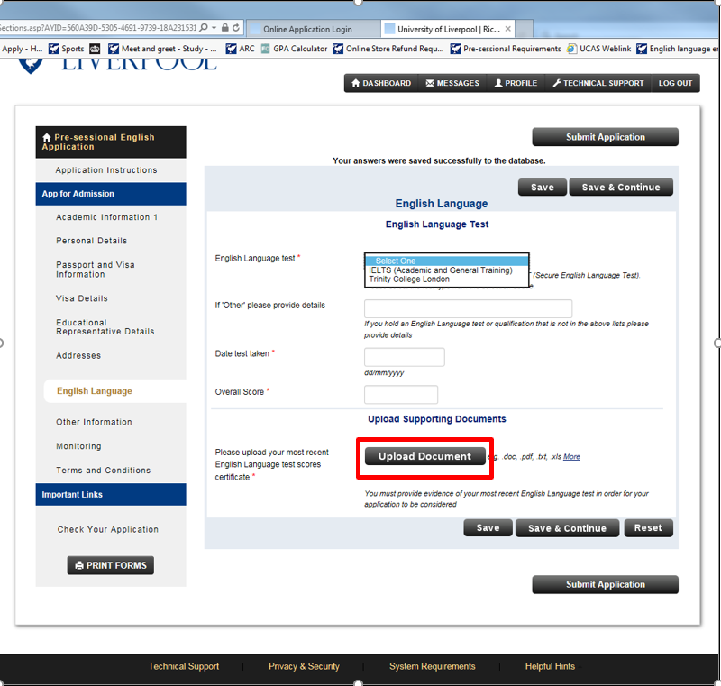

## Other Information

## Finance

International students who require a Student Visa to study in the UK should be advised that UK Visas and Immigration (UKVI) will require them to provide evidence that they can meet the cost of their course fees for the upcoming year and living costs for the duration of the time they will be in the UK.

For information about the Student Visa application process, please visit our International Advice and Guidance team pages: <https://www.liverpool.ac.uk/studentsupport/international/visas/>

## Funding

* Select your funding source (Self-funded or Sponsored)

**Personal/Family resources/Self-funded** – If you intend to pay your fees this way, please note that a £1000 deposit is required and will be a condition of any Pre-sessional English course offer.

Please use the online payment facilities available on the English Language Centre website. This is a quick and secure payment option and will ensure that there is no delay in the processing of your application: [Online Payment Facilities.](https://www.liverpool.ac.uk/english-language-centre/pre-sessional-english-courses/dates-and-fees/fee-payment/)

You can find information about cancellation of your order (deposit) after a payment has been made in the Pre-sessional English Payment policy available here:

<https://www.liverpool.ac.uk/english-language-centre/policies-and-documents/>

**Sponsorship** – If you are a sponsored student, please include a full copy of your official sponsorship letter with your application. If your sponsor fails to pay your tuition fees, the liability for such payment will be transferred to you.

* If you are a sponsored student, please provide details of your sponsor in the box. Please also answer **Yes** or **No** to the question highlighted to indicate whether or not you have a copy of your financial guarantee letter. If you have answered **Yes**, please upload a copy of the letter using the **Upload Document** button.

If you do not have a copy of a valid financial guarantee, provided you meet the entry criteria of the Pre-sessional EAP course that you have applied for, our Admissions Team can issue a conditional offer to you when your application has been processed.

Please be aware of scholarship deadlines that may apply when submitting a new application. It can take our Admissions Team several days to process an application and to issue an offer.

* Click **Save & Continue** to move to the next section.

## Monitoring

In this section applicants should declare any disability and state their ethnic origin. Any information disclosed in this section will remain strictly confidential. Information is used for monitoring and equal opportunities purposes and to ensure that the university is able to provide students with appropriate facilities.

## Disability and Ethnic Origin

Information disclosed relating to disability and ethnic origin does not form part of the decision-making process and will not affect whether an applicant receives or does not receive an offer of a place at the University of Liverpool.

Select the appropriate choices from the drop-down menu as shown on the following page.

## Terms and Conditions

* Tick the box to indicate that you have read and accept the terms and conditions listed.
* Tick to confirm if you happy for a trusted Educational Partner to contact you regarding your application to University of Liverpool or regarding the visa application process. You are agreeing to your details being shared with third parties managed by the University of Liverpool.
* Click **Save & Continue**.

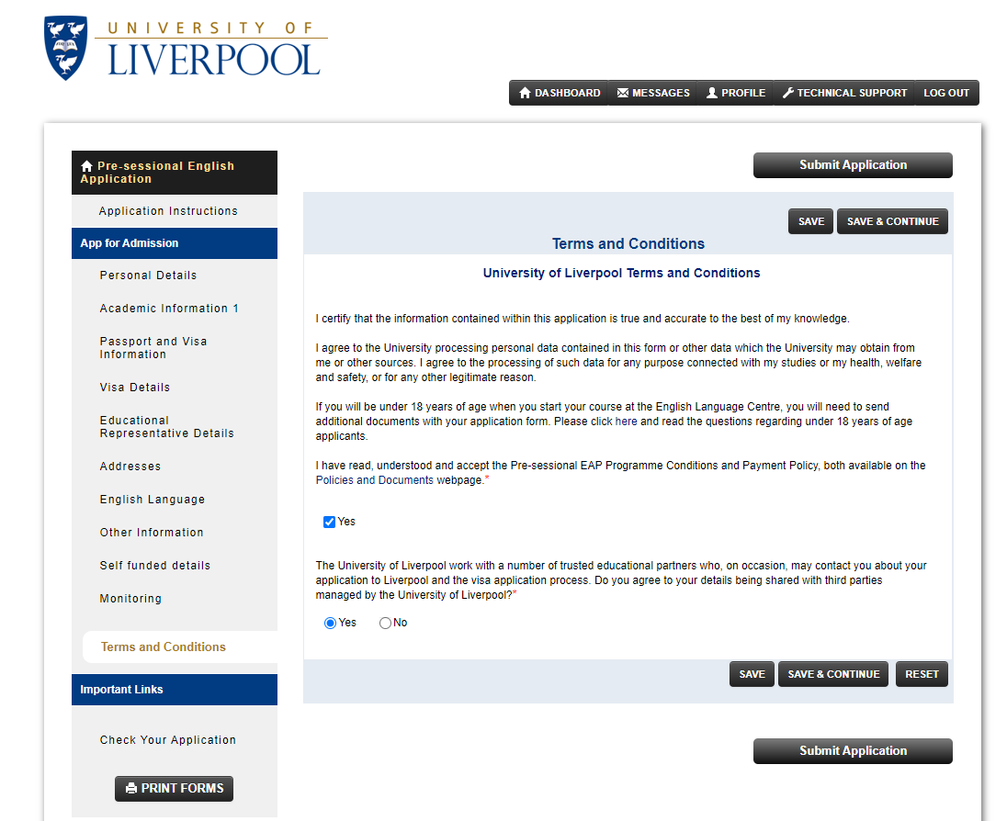

## Submitting the Application

Once all sections have been completed with the minimum required responses then the **Application Status** will state: **Ready for Submission**. Please provide all available information at this time, and ensure any further questions that can be answered prior to submission are completed.

The completed application can be reviewed in PDF format (including any uploaded documents) by clicking on the link highlighted below. Please ensure that all information is accurate as the information cannot be changed once the application has been submitted.

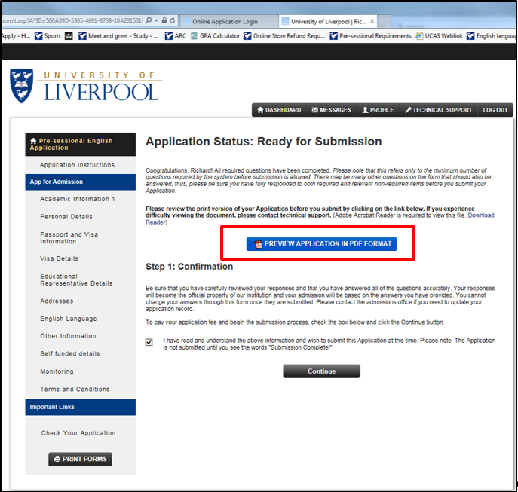

* When satisfied that the application is ready for submission, tick the box and select **Continue**.

**This is the final step in the application submission process.** No changes to the application through the online system are allowed once the application is submitted.

* Enter your digital signature in the box. Today’s date will be automatically populated.
* Click the **Submit Application** button.

**Pre-sessional English for Academic Purposes (EAP) Course Conditions**

Please read the conditions below carefully. By submitting an application, you are confirming that you have read, understood and accept the following information:

* Progression onto your academic programme for the following academic year is notautomatic. To progress on to your University of Liverpool academic Undergraduate or Postgraduate programme, you must successfully complete the Pre-sessional EAP course or achieve the direct English Language requirement and successfully achieve any academic conditions.
* Please check your Undergraduate or Postgraduate offer for further details. If your academic offer letter contains both academic and English conditions, you will need to satisfy both of these conditions to ensure that you can progress on to your academic programme. If you do not meet the academic conditions of your offer, you will not be able to progress to academic study in September 2024/25.
* It is your responsibility to ensure that your academic qualifications are at the required level to progress on to a degree programme.
* The English Language Centre is not responsible for your academic offer. If you have not received an offer email for your academic study, you should contact the International Admissions Team directly and request this.
* If you have an academic offer from a different UK institution, it is unlikely that they will accept successful completion of the University of Liverpool Pre-sessional EAP course as a measure of your English. You will need to meet the Institution’s specific English Language requirements. Please check that the Institution will accept a Pre-sessional EAP course completed at the University of Liverpool.
* You will take a number of in-house assessments throughout your course to ensure that you are making sufficient progress. Progression from one stage to the next is not automatic and it will depend on the results of assessments you take during your course.
* If the English Language condition in your academic offer does not refer to the Pre-sessional EAP course, you are welcome to apply for the Pre-sessional EAP course but please be aware that you will be required to take an IELTS examination on completion of the Pre-sessional EAP course.
* If you intend to progress to a programme that will not accept the Pre-sessional EAP course as evidence of English Language, you must book your IELTS examination at the earliest opportunity due to the popularity of our IELTS examination at the English Language Centre’s IELTS Centre. We will not arrange this test for you.
* In order to enrol on the Pre-sessional EAP course, you must achieve the required IELTS score and obtain a Student Visa. You must use your University of Liverpool Pre-sessional EAP CAS to do so. A CAS for our Pre-sessional EAP courses will only be issued following an offer and on receipt of confirmation of intent to study, and the full payment of non-refundable deposit or a certified letter of sponsorship that guarantees financial support.
* The course comprises of approximately 18 hours of lessons and tutorials and approximately 20 hours per week of directed self-study after class and at weekends. You must aim to attend your Pre-sessional EAP course all of the time. Failure to do so may be a violation of your Student Visa agreement and the UK Visas and Immigration (UKVI) will be notified.
* In accordance with UK Visas and Immigration guidelines, if you have a Student Visa and decide to withdraw or suspend studies from the course, you will need to return to your home country.  
  The University of Liverpool is required to pass on details of students who do not commence on their start date or who leave their course early to the UK Visas and Immigration.
* If you are a sponsored student, you must provide a hard copy of a Financial Guarantee to the English Language Centre before, or no later than, the start date of the course. You will not be permitted to study without this.
* If you arrive after the specified latest possible start date for your course, you will not be allowed to start the course and will be required to return home. Details of latest possible start dates and application deadlines can be found on the ELC website.
* You accept that that the University of Liverpool reserves the right to change these conditions without prior notice.

**By signing the application form and submitting the application, you are acknowledging and agreeing to the conditions as stated in this document.**