­­­

Contents

Postgraduate Certificate Academic Practice (PGCAP) Mentor Guidance 2024-25

|  |  |
| --- | --- |
|  | Page |
| Welcome and Contacts | 3 |
| Purpose of Mentoring | 4 |
| Mentor Support | 3 |
| The Role of the Mentor | 4 |
| Benefits of Mentoring | 6 |
| PGCAP Information | 6 |
| PSF (2023) Information | 7 |
| Observations of Teaching to authenticate practice | 9 |
| Appendix A - Authentication of Practice Recording Form  Appendix B – Mentor Agreement Form  Appendix C – PGCAP Mentor Meeting Form | 11  14  15 |

**Welcome**

We would like to take this opportunity to thank you for agreeing to act as a mentor for participants on the PGCAP programme. We view this as an extremely important and valuable role and appreciate you taking on this responsibility. We hope the following information will help you to be aware of what is involved in this role, as we believe it is crucial our participants are supported appropriately to develop in a challenging environment. Your role of mentor is therefore paramount in enabling this to happen. Underpinning this role is the notion of a two-way relationship, with both parties encouraged to have mutual respect and value for each other as colleagues and fellow professionals.

Please do not hesitate to contact us if you have any questions or think we can give you any further assistance in this role.

Judith Schoch

[J.Schoch@liverpool.ac.uk](mailto:J.Schoch@liverpool.ac.uk)

Admin Contact for The Academy

Sandra Jamieson

[theacademy@liverpool.ac.uk](mailto:theacademy@liverpool.ac.uk)

**Purpose of Mentoring**

To provide support to those who are undertaking the Postgraduate Certificate Academic Practice (PGCAP) and authenticate practice through observation of teaching, learning and assessment. Being a PGCAP mentor is voluntary.

**What is Mentoring?**

Mentoring is essentially about supporting others to develop more effectively. Mentoring is not teaching or training, although has elements of coaching at times. A mentor needs to be someone who can listen and ask the right questions to challenge the participant to identify what they need to do in order to develop. In a mentoring relationship, attitude, motivation and skills can be identified, and these apply to both the mentor and the participant. In adult learning the responsibility for learning is on the learner, so the participant must take some of the responsibility for the success of the mentoring relationship. Mentors provide support to help participants by drawing on their own experience, and being a ‘critical friend’.

**Prerequisites for Mentors:**

* Be a member of staff at University of Liverpool
* Have achieved recognition as a Fellow, Senior or Principal Fellow of the HEA
* Completion of a PGCAP or equivalent is desirable but not essential
* Be a Fellow, Senior Fellow or Principal Fellow of the Higher Education Academy
* Attend Mentor Development Session
* Commit to attending termly Mentor Network Meetings
* Declare any conflict of interest

**Mentor Support**

All PGCAP mentors will be supported through regular PGCAP Mentor Network Meetings which will run x3 times per year and take the form of an informal face to face or online meeting. The meetings are to support mentors and give them an opportunity to discuss with colleagues, positive aspects of mentoring and any challenges, concerns or ideas that you have for mentoring, in a confidential and supportive environment. All PGCAP mentors will also be members of a Teams community of practice with informal asynchronous conversations with other programme mentors. PGCAP mentors will be expected to attend Mentor Network Meetings and participate in the conversations in the Teams community of practice.

|  |
| --- |
| 1. The Role of the Mentor |
| Be part of a community of practice and attend termly Mentor Network Meetings |
| Once you have been put in contact with a participant, agree a procedure for scheduling mentoring meetings and communicating with your participant in line with reasonable professional expectations of the role |
| Arrange meetings with the participant to provide feedback and guidance on their progress and development whilst they are on the PGCAP programme. |
| Arrange meetings with the participant to provide feedback from any observations undertaken to authenticate practice |
| Be conversant with the PSF (2023) and use this as a consistent reference point when providing guidance and advice |
| Be committed to, and supportive of, the participant’s progress and development by challenging them to improve their performance and outlook as a professional practitioner |
| Support the participant to engage with the Programme modules, observations of practice, assessments and the PSF (2023) |
| Encourage the participant to engage in critical self-reflection and evaluation of their own learning, teaching and assessment and support of students |
| Support the ‘action planning’ process and encourage the participant to take responsibility for creating and determining their own actions |
| Support the participant in reflecting on their current and future continuing professional development |
| Maintain a dialogue with the PGCAP team, Module Leads and/or Director of Studies |
| Where work is unsuccessful, assist the participant in responding to the feedback received |

|  |
| --- |
| Mentors are NOT expected to: |
| Compile any of the work for assessment on behalf of the participant |
| Have the same subject background as the participant |
| Proof-read or provide detailed corrections to work |

**Benefits of Mentoring**

Being a mentor will support you in your own continuing professional development. It will also strengthen your own awareness of learning, teaching and assessment practiced by your colleagues. Mentoring can help you to generate some evidence, perhaps for one case study, required for Senior Fellow (D3) by helping you to demonstrate your contribution to supporting the development of colleagues’ effective and inclusive practice. For those who are Senior Fellows, it will support you in maintaining your good standing and sharing good practice.

**PGCAP Programme Information**

The PGCAP is accredited by Advance HE and enables colleagues with substantive teaching responsibilities to gain a teaching qualification and recognition of Fellow of the HEA. It is for those staff who work in a teaching role at the University of Liverpool, and aims to support and enhance the development of a rich, diverse learning and teaching culture. The Programme is work-based and flexible, drawing on participants' experience as learners, teachers and professionals within the University. The Programme is intended to contextualize this professional practice within an approved and accredited reflective pedagogic framework.

The main aims of the Programme are to encourage the development of high-quality academic practice that enables teaching staff to gain a teaching qualification, and professional recognition, and support them to develop the knowledge, skills, expertise and values necessary to sustain effective academic practice and support student learning in line with the University of Liverpool’s Strategic Educational Objectives. Please see [PGCAP Website](https://www.liverpool.ac.uk/eddev/supporting-teaching/pgcap/) where you will find the PGCAP Handbook and information about the PGCAP schedule of workshops and the Professional Standards Framework (PSF 2023).

**The Professional Standards Framework (PSF 2023)**

The PSF is a descriptor-based framework and provides a general description of the main dimensions of the roles of teaching and supporting learning within the HE environment. It forms the basis for the award of four categories of HEA Fellowship, Associate Fellow, Fellow, Senior Fellow and Principal Fellow. Fellowships are awarded depending on an individual’s role and experience, and on the basis of successful and effective demonstration against the PSF.

The framework identifies the diverse range of teaching and support roles and environments, which are expressed in the Dimensions. Engagement with these dimensions forms the basis of all HEA Fellowship applications and the type of engagement, described as ‘descriptors’, is differentiated according to the level of fellowship. You will find a copy of the framework on the website and in your Mentor Teams space.

**The Professional Standards Framework (PSF)**

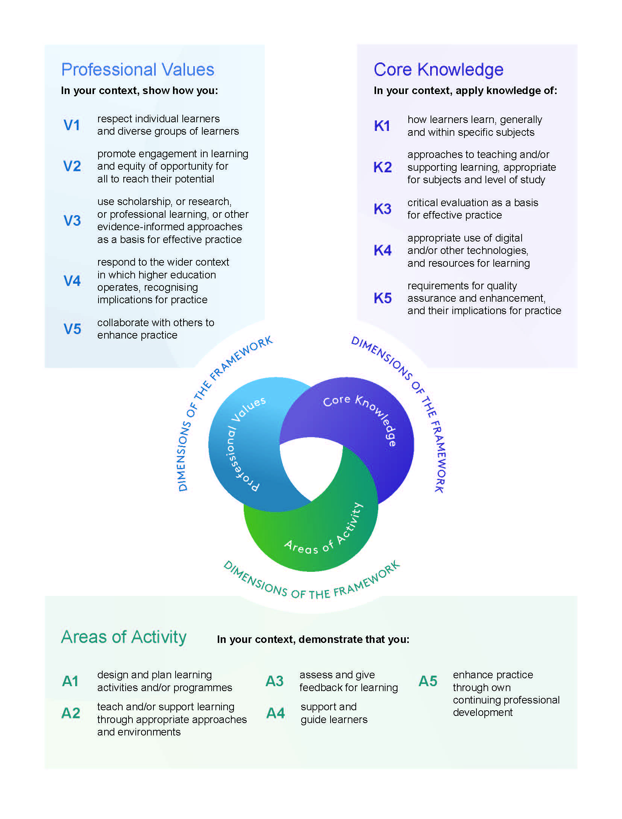

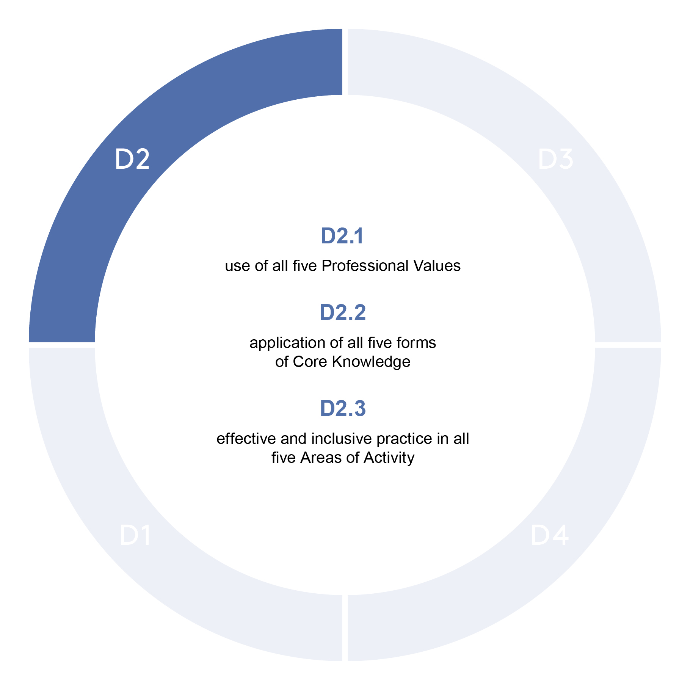

**Key Changes to PSF 2023 for D2**

The PSF 2023 builds on the strengths of the UKPSF 2011 and places more overt emphasis on:

* The effectiveness and impact of teaching
* The context in which the teaching takes place
* Inclusivity – both from the perspective of the wider range of staff now able to engage with the PSF and how more inclusive approaches ensure all learners feel respected, valued and have equity in opportunity to succeed
* There is greater emphasis on **digital/technology, professional values, support for students and collaboration**

|  |  |
| --- | --- |
| Introduction | D2 is suitable for individuals whose practice with learners has breadth and depth, enabling them to evidence all Dimensions. Effectiveness of practice in teaching and/or support of high-quality learning is demonstrated through evidence of: |
| D2.1 | **Use** of all Professional Values |
| D2.2 | Application of all Core Knowledge |
| D2.3 | **Effective and inclusive practice** in all five Areas of Activity |

**Observations of teaching to authenticate practice**

As a mentor for a participant undertaking the PGCAP you may be asked to carry out an observation of learning, teaching and assessment to authenticate practice in order to meet the requirements for HEA fellowship. The observation process is not about judging performances, but about mutually beneficial learning conversations between colleagues. You will attend a PGCAP Mentor Development Session to discuss peer observations, along with general guidance on mentoring linked to helpful models and literature. Slides from the session will be shared on the Mentor Teams space. You will need to attend the PGCAP Mentor Development Session prior to mentoring a participant.

It would also be beneficial for you to attend UoL’s observation development session prior to carrying out an observation, which can be booked through CoreHR.

An observation should include three key elements:

* **A pre-observation meeting** which is an opportunity for the participant to give you an overview of the observation and objectives of the learning activity. The meetings can be arranged in person or online.
* **The Observation** itself
* **A post-observation discussion** which is an opportunity to encourage the participant to critically reflect on their observation, and for you to offer support and suggestions to create development actions.

In **preparing** for the Observation you should:

* ensure you have a copy of the PGCAP Authentication of Practice recording form
* ensure you have a copy of the PSF 2023
* have a means of recording thoughts and ideas during the session
* check, as far as possible, that the normal pattern of learning is not disturbed or disrupted by the observation
* offer immediate verbal feedback where possible, recognising that this will need to be supplemented by comments in writing which are shared at a subsequent feedback meeting

**The Participant should provide you with:**

* planning documentation
* copies of resources to be used, including presentations and handouts
* a module handbook or specifications, if applicable
* assessment information, if relevant
* feedback from any previous observations where relevant

**Recording an Observation**

Formal feedback to participants is recorded on the Authentication of Practice form (Appendix A). Please ensure that the form is completed with the use of the PSF to help contextualise developing practice in light of D2. Following the feedback meeting, a completed copy of the form will be given to the participant to agree and sign.

**Giving feedback**

It is important that the feedback given to your participant should be ***constructive*** and ***developmental.*** It is suggested that ideally two kinds of feedback should be offered following an observed session.

**Firstly,** some spoken generalised feedback as soon as possible after the session, intended to offer some response to the lecturer/practitioner who may be anxious to know the Mentor’s reactions.

**Secondly,** arrange some time after the observation to have a full de-brief session around the written report completed on the PGCAP Authentication of Practice form. This has the advantage of the Mentor having a chance to think through what is important enough to record and discuss. It also allows the Participant to gather their own thoughts about the session and to make their own appraisal of the observation.

**Guidelines for Giving Feedback**

The Mentor should:

* Focus on behaviours that can be enhanced
* Limit the amount of feedback to that which your participant can cope with
* Make positive suggestions for improvement
* Avoid making value judgements
* Use questions to guide the discussion
* Encourage your participant to engage in reflection at a personal and professional level
* Encourage your participant to critically reflect using the PSF

**Appendices:**

* Authentication of Practice Recording Form
* Mentor Agreement Form
* PGCAP Mentor meeting form

**Appendix A**

**PGCAP AUTHENTICATION OF PRACTICE RECORDING FORM 2024-25**

**To Be completed by PGCAP Participant:**

**Date of Session:** Click or tap to enter a date. **Session Type:** Choose an item.

**Observee:** Click or tap here to enter text. **Mentor (if applicable):** Click or tap here to enter text.

**Observer:** Click or tap here to enter text. **Observer HEA Fellowship:** Choose an item.

**Subject:** Click or tap here to enter text. **Topic of session:** Click or tap here to enter text.

**Add a rationale and context of session taking into consideration subject, students, planning, teaching and learning methods/strategies:** Click or tap here to enter text.

**Please identify any specific aspects of session that you would like observer to feedback on:** Click or tap here to enter text.

**To be completed by Observer:**

**Please confirm that you have read the Observer Guidance to Authenticate Practice**: Choose an item.

**Please confirm if you have attended UoL’s Peer Observation Development Session**: Choose an item.

The PGCAP is aligned with the Professional Standards Framework (PSF) 2023, and the comments and developmental feedback should be made with Descriptor 2 in mind. Participants should be able to provide evidence of successful engagement in appropriate teaching practices related to the following Professional Values, Core Knowledge and effective and inclusive practice in Areas of Activity.

**Observer, please highlight dimensions you think the participant has met in this observation**

|  |  |  |
| --- | --- | --- |
| Professional Values | Core Knowledge | Areas of Activity |
| V1 respect individual learners and diverse groups of learners  V2 promote engagement in learning and equality of opportunity for all to reach their potential  V3 use scholarship or research or professional learning, or other evidence-informed approaches as a basis for effective practice  V4 respond to the wider context in which higher education operates recognising implications for practice  V5 collaborate with others to enhance practice | **K1** how learners learn, generally and within specific subjects  **K2** approaches to teaching and/or supporting learning, appropriate for subjects and level of study  **K3** critical evaluation as a basis for effective practice  **K4** appropriate use of digital and/or other technologies, and resources for learning  **K5** requirements for quality assurance and enhancement, and their implications for practice | **A1** design and plan l earning activities and/or programmes  **A2** teach and/or support learning through appropriate approaches and environments  **A3** assess and give feedback for learning  **A4** support and guide learners  **A5** enhance practice through own continuing professional development |

**Overall Summary of Strengths and Areas of Development**

**Strengths:** Click or tap here to enter text.

**Areas of Development:** Click or tap here to enter text.

­­­­­­

**Planning and Preparation for the Session** - lesson planning, learning objectives, activities, assessment, employability, resources, quality and level of learning materials, physical environment, module handbooks

Click or tap here to enter text.

**Introduction -** clarification of learning outcomes and overview of session, links to previous learning

**Communication –** pace, use of voice, language, body language, eye contact, listening skills, confidence, clear explanations, management of session

Click or tap here to enter text.

**Classroom interactions and student engagement -** motivating students, student participation, interaction, promoting engagement in learning, equity of opportunity for all students, commitment to studies, effective stimulation and challenge, approaches to teaching and/or supporting learning, appropriate for level and subject

Click or tap here to enter text.

**Examples/Application** – theory to practice, relevant literature, intellectual stimulation, workplace learning, self-reflection, independent learning, employability, sustainability

Click or tap here to enter text.

**Accommodation and Resources** – managing an appropriate learning environment, effective use of physical and digital resource, support of independent study and research skills, quality of materials used, specialist equipment if relevant, digital technology

Click or tap here to enter text.

**Assessment and Feedback for Learning** – student progress, attainment and achievement, support of students’ development, clear criteria, relevant immediate feedback that supports learning and understanding

Click or tap here to enter text.

**Inclusive Practice** – respect for individual students and diverse groups of students, support and guiding students, race equality, culture and language, equity of opportunity for all to reach their potential, personalised needs and learning, stretch, challenge and rigour,

Click or tap here to enter text.

**Subject discipline context and content** – topics within subject area, application to practice, up-to-date knowledge, appropriate literature, examples and analogies as a basis for effective practice

Click or tap here to enter text.

**Digital technology –** appropriate use of, resources for learning, AI

Click or tap here to enter text.

**Conclusion/Plenary** – summary of key points and ideas, follow up material or activities, links to next session

**Suggested Areas for Further Development/CPD sessions (A5)**

Click or tap here to enter text.

**­­­­­­­­­­­­­­­­­­­­**

**AUTHENTICATION OF PRACTICE**

**We agree that this is a fair record of the observation and post observation discussion:**

**Signature of Observee** Click or tap here to enter text. **Date** Click or tap to enter a date.

**Signature of Observer** Click or tap here to enter text. **Date** Click or tap to enter a date.

**_________________________________________________________________________________**

**To be completed by PGCAP Participant for one observation after Observation Feedback Meeting:**

**Patch 3 - Self-evaluation and reflection of the session (500 words)**

Try to capture your immediate thoughts after the observation. How did your session meet the aim and outcomes, including consideration of student needs, learning environment, student engagement and feedback? What went well? What could have been improved? What are your main developmental action points?

**Please also map to the PSF at D2 and underpin with any relevant literature, frameworks, strategy or policy that may influence your thinking and future development, with a reference list.** Create main action points that you can develop for future practice.

Click or tap here to enter text.

**Appendix B**

**PGCAP Mentor Agreement**

**Mentor: ​**Click or tap here to enter text.**​**

**Participant: ​​**Click or tap here to enter text.**​​**

**Start Date: ​**Click or tap to enter a date.**​**

**Anticipated End Date: ​**Click or tap to enter a date.**​**

**Participants goals for overall mentoring relationship** (2 or 3 main goals/actions)**:**

**​**Click or tap here to enter text.**​**

**Success Measure** (how will you know ‘goals’ above have been successful?)**: ​**

Click or tap here to enter text.**​**

**Ground rules in the mentoring relationship** (eg. confidentiality, proactivity, responsibilities...)

​Click or tap here to enter text.​

**Roles and Responsibilities ​**

Click or tap here to enter text.**​**

**Frequency of meetings (**note how often you will meet, eg. once a month) ​

Click or tap here to enter text.​

**Appendix C**

**Postgraduate Certificate in Academic Practice (PGCAP)**

**MENTOR MEETING FORM**

|  |  |
| --- | --- |
| **Name of Participant: ​**Click or tap here to enter text.  **​** | **Name of Mentor: ​**Click or tap here to enter text.**​** |
| **Review of action points from previous meeting** (if applicable)**: ​**Click or tap here to enter text.**​** | |
| **Overview of meeting discussion** (in first meeting, you may wish to discuss expectations of the mentoring relationship; agreement on how often to meet; agreement on type of support needed or offered)**: ​**Click or tap here to enter text.**​** | |
| **Action points agreed from meeting** (main action points for development or support from the discussion)**: ​**Click or tap here to enter text.**​** | |

Participant Signature: ​Click or tap here to enter text.​

Mentor Signature: ​Click or tap here to enter text.​

Date: ​Click or tap to enter a date.​